Optimizing in the Dark:

How Organizational Blindness to Uncertainty Makes AI Development Ineffective

Chapter 1: Iterating towards a random target

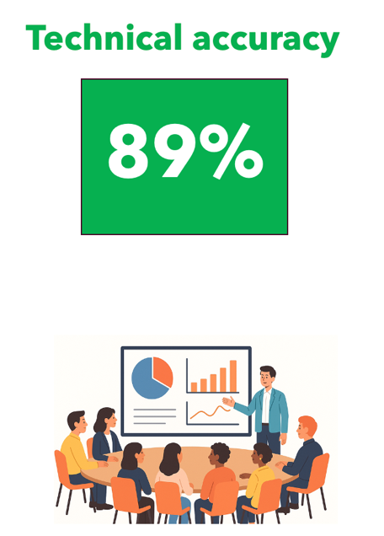
A Structural Flaw in Judgment

You have all been in this room. A slide goes up. There’s a metric - “Technical Accuracy”, a number: 89%, and a color – green..

Getting these metrics, numbers, and even the colors “right” are foundational to the success of a product.

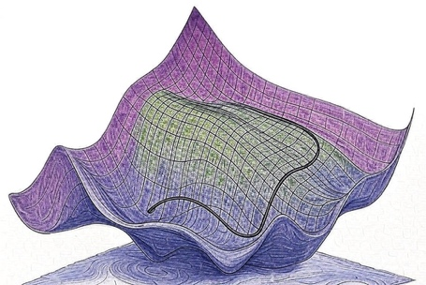

They are the final output of a complex process of decisions and actions. This output is very consequential. Not only they determine ship / no ship decisions, but they tell engineers where to focus.
To some extent they act like a loss profile and give us axes along which we need to improve our product.

And as AI takes more of a leading role, they also tell AI where to improve - helping us make the “AI code generation - Evaluation” loop effective. Conversely, if we get these wrong, we iterate in the wrong directions, we ship things that make our customers lose trust in us, we hold back great features that could help us win deals.

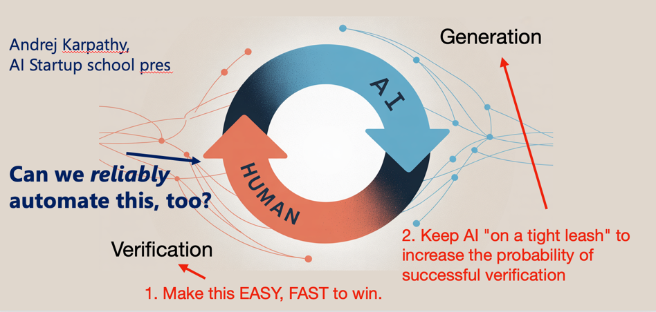

As I sit in the room and listens to presentations and reports, I wonder: how reliable are these numbers? Do the team reporting on the results know? And do we, sitting in the room, know?
Do we grasp what that means for the decision we’re about to make?
Do we know how much brittleness, uncertainty, noise, variance, and bias is hiding in that “accuracy, green 89%”?

Walter Lewin, the MIT physicist, in his first lecture of the course in basic Physics tells his students: “Any measurement, without knowledge of the uncertainty, is meaningless.” Not “less precise.” Not “directionally useful.” Meaningless. Then he adds: “I want you to hear this at 3am tonight when you wake up.” He says this in the first lecture of the first course on Physics, not at some random point.
And, he was talking to people who live in the science of measurement. We are not in that world. We are evaluating and reporting “at scale” across many use cases and teams, with vastly diverse audiences ranging from engineers to scientists to executives.

So, the number in itself may be meaningless, but the act of reporting it makes it worse, it makes it misleading.
My experience is that people rarely realize this.
A common tendency in organizations is to wash this question away based on the idea that “we are engineers, we are so cool because we approximate, and iterate. A measure may not be perfect, it’s a hint, we will improve over time. We crawl walk run”
But having a sense for how biased and noisy our measures can be is central to the notion of “engineering approximation”. More specifically

A measurement is harmful if it does not let me drive product improvement iterations
in the right direction.

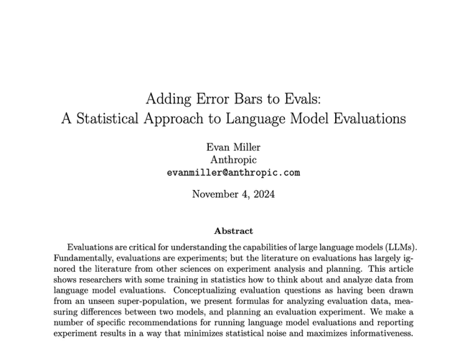
I started paying closer attention to this problem when Anthropic published a paper titled “Adding Error Bars to Evals.” I thought: “It’s about time people in this industry begin making this point”.

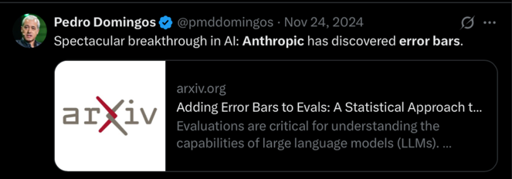
The reaction on social media, however, was quite instructive. Pedro Domingos said: “Spectacular breakthrough in AI: Anthropic has discovered error bars!” The sarcasm was widespread. “What an unserious field”, people said, that needs to be told to add error bars.

The mockery proved the paper’s point. If this were obvious and practiced, the paper wouldn’t exist. The fact that a leading AI lab felt the need to write it - and the fact that the community’s response was ridicule rather than embarrassment - tells us where we are.

Around the same time, I came across Kahneman, Sibony, and Sunstein’s book “Noise. A Flaw in Human Judgment”
One of its central observations is that organizations systematically underestimate - and resist acknowledging - variability in human judgment. We prefer consensus and harmony. We don’t want to see the noise.
That resonated with my experience.

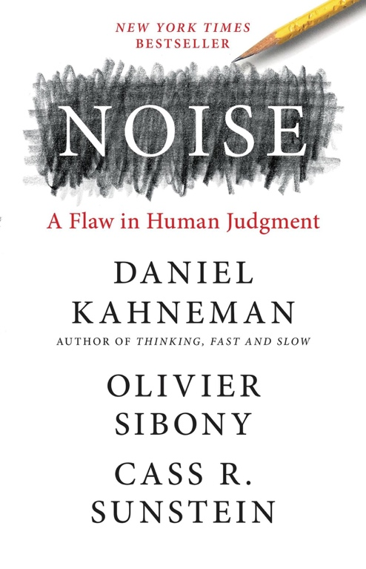
Even more insightful was the experience I had from discussing it with a friend working at an AI company in the Valley. His response after reading it was: “Yeah, the book is pretty useless. We know there’s a standard deviation.”. This is the same kind of response that the Anthropic article received.

Yes, there’s noise, and variance - and we don’t know
- how large it is,
- where it comes from,
- how much it’s costing us, or
- how to reduce it.

And noise and variance are only part of the problem. Measurement processes can be – and typically are - systematically biased — consistently producing results that are too optimistic, or, more rarely, too pessimistic, or simply measuring the wrong thing. In fact, as we will see, most processes are intrinsically biased.

What Kahneman helped me see is that this isn’t just a skills gap. It’s structural. Organizations have never had to rigorously measure the quality of machine judgment and have never had to deal with measurements that have so much uncertainty and this level of complexity. The muscle doesn’t exist - and it is unclear even if the right incentives to develop it are in place.

This is the problem I want to talk about: we are building highly consequential AI systems, making decisions based on evaluation numbers, and we are systematically both underestimating and ignoring the bias and uncertainty in those numbers.

This begs the question: who bears responsibility? Is it the person presenting? The person who designed the reporting template? The team that delivered evaluation tools? The executive who doesn’t ask? The culture that punishes uncertainty? Or, the natural unwillingness of organizations to accept the existence of variability and noise within a structured process?

The question is hard also because the “problem” landscape has three distinct facets:
- The visibility problem (epistemic): People don’t see the uncertainty. It’s not reported, not computed, not surfaced. The green 89% looks solid. Decision-makers can’t account for what they don’t know exists.
- The culture problem (organizational): Even when people could see uncertainty, the organization doesn’t ask. We don’t reward quantifying it. We don’t penalize ignoring it. The question “how confident are we?” isn’t part of the discussion process. Uncertainty stays invisible because making it visible has no upside and potential downside (looking less confident, slowing things down).
- The action problem (methodological): Even when uncertainty is visible and the culture asks about it, people don’t know what to do. How do you decide when the range is 77-95%? How do you reduce variance when you don’t know which source dominates? The frameworks and practices are neither widely known now well-established in gen AI.

To understand why evaluation practices erode as we move toward gen AI, we need to look at how engineering evolved across Software 1.0, 2.0, and 3.0.

The Cost of Inaction

It’s easy to talk about noise as an abstract annoyance—“sure, the metric is a bit noisy, but directionally it’s fine.”
Every score is the output of a measurement pipeline—and that pipeline injects both uncertainty and bias. Whether we can wash away current eval imperfection as “engineering approximation” depends on how large they are.

Every Score Has Two Error Terms: Bias and Uncertainty
For a given use case i, the reported score is not just a function of system quality. It is an estimate:
reported_scoreᵢ = true_scoreᵢ + Bᵢ + εᵢ
Where:
- εᵢ is noise (assume it is random error): sampling variance, stochastic judge variance, rater inconsistency, prompt sensitivity, rubric interpretation variance, etc. This is what produces uncertainty (UNᵢ), typically visible as a confidence interval or run-to-run variability.
- Bᵢ is bias (systematic error): non-representative test sets, rubric misalignment with user value, proxy metrics that reward the wrong behavior, judge preference artifacts, contamination/leakage, over-representation of “easy” cases, and other consistent measurement distortions.
Two implications matter operationally:
- Uncertainty is often measurable. Bias often isn’t. You can estimate run-to-run variance. You can compute confidence intervals. But bias can hide behind stability. The most dangerous situation is a tight error bar around the wrong number.
- Bᵢ and UNᵢ vary by use case. Some use cases are “measurement-friendly” (their eval pipeline is optimistic). Others are “measurement-hostile” (their eval pipeline is pessimistic). A portfolio that treats all scorecards as equally valid is not making a ranking—it’s making a decision using unknown and uneven measurement error.

Two Kinds of Cost: Random Mistakes and Systematic Mistakes
At scale, both noise and bias hurt—but they hurt differently.
- Noise (variance) creates random wrong turns: you invest in the wrong variant, pause the wrong project, chase an improvement that wasn’t real.
- Bias creates systematic wrong turns: you consistently overestimate what’s ready, consistently favor what’s easy to score, consistently “prove” progress on the slide deck that won’t show up in production.

Selection turns noise into bias.
Even if each individual evaluation were unbiased, the act of picking winners creates systematic optimism. The measurement process starts neutral. The decision process makes it lopsided. The math is real.

The Single-Use-Case Cost: When One Scorecard Misleads You
A portfolio problem is made of many local problems. Even inside a single use case, bias and uncertainty create expensive failure modes.

The Threshold Trap (false positives at ship/no-ship boundaries)
Most decisions are threshold decisions: ship if score ≥ T.
But if:
reported_score = true_score + B + ε
then a small positive bias can dramatically increase the chance that an unready system crosses the threshold.
Example (illustrative): T = 85, σ = 4 points, true = 80
Bias B | What you’re effectively measuring | Probability you ship even though true < T
0 | 80 + noise | ~11%
+3 | 83 + noise | ~31%
+5 | 85 + noise | ~50%
A few points of bias does not “nudge” the decision—it can double or triple the false-positive rate.

The Directional Illusion (optimizing the ruler, not the system)
Within one use case, teams iterate quickly and celebrate small gains: +1, +2, +3 points.
But if those changes are within UN, what looks like progress is often just noise. That creates predictable waste:
- false wins (“we improved!”),
- false regressions (“we broke it!”),
- thrash between variants,
- and over-engineering to chase a moving number.
The waste is invisible because the work feels productive. Metrics fluctuate. Experiments complete. Sprints close. But a meaningful fraction of effort is spent climbing hills that don’t exist.

Bias Lock-In (early measurement becomes architecture)
Early evaluations are typically the most biased:
- weak rubrics,
- small or unrepresentative datasets,
- uncalibrated judge prompts,
- missing edge-case coverage.
Yet early evaluations drive the most irreversible choices: architecture, approach, tooling, and definitions of “good.”
If early measurement is biased, you don’t just waste one sprint—you build a system that is locally optimal for a flawed measurement process.

The Portfolio Winner’s Curse (Now With Bᵢ and UNᵢ)
Now scale up.
Suppose you have U use cases, each with a reported score:
reported_scoreᵢ = true_scoreᵢ + Bᵢ + εᵢ
Even if εᵢ averages to zero across evaluations, the best-looking score among many will be “lucky.” This is the same phenomenon as best-of-K selection inside one use case—except now it operates across your entire portfolio.

Winner’s curse from noise (ε): extremes are disproportionately luck
Table: Expected optimism from picking the best-looking item among many
(E[max noise] is in units of σ, the standard deviation of your evaluation noise; Gaussian approximation.)
Candidates compared | Expected “winner’s bonus” (E[max]/σ) | If σ = 4 points
10 | ~1.54σ | +6.2 points
50 | ~2.25σ | +9.0 points
100 | ~2.51σ | +10.0 points
500 | ~3.04σ | +12.1 points
Interpretation: if your evaluation pipeline has σ ≈ 4 points (not unusual once you include sampling noise, judge noise, and rubric mapping), then in a portfolio of ~50 use cases, the “top” use case is expected to look ~9 points better than it truly is—even if all use cases had identical true quality.

Winner’s curse from bias (B): the portfolio selects measurement-friendly use cases
Noise is only half the story. In real portfolios, Bᵢ varies.
That means portfolio selection doesn’t just surface the best systems. It systematically surfaces:
- use cases whose measurement pipeline is optimistic (high Bᵢ), and
- use cases with higher variance (high σᵢ), because they generate more extreme “wins.”
This is how organizations drift toward “demo-friendly” and “metric-friendly” work. It’s not because people are dishonest. It’s because the system rewards what measures well.

Selection happens repeatedly, so optimism accumulates
Organizations don’t select once. They select repeatedly:
- Each team selects the best prompt or pipeline variant for their use case
- Leadership selects the best use cases across teams
- PMs select the best demos for executive review
- The organization selects the “reference implementation” everyone copies
Each selection step preferentially surfaces outcomes inflated by ε (luck) and, over time, biased toward use cases with favorable B.
By the time something becomes a showcase or a standard, it has survived multiple rounds of selection—which means it has accumulated multiple rounds of optimism.

Misranking Is Not Rare—It’s the Default When Differences Are Small
Portfolio decisions often hinge on small score differences: “Use case A is 84%, B is 88%—let’s invest in B.”
But if measurement noise is comparable to those differences, you are ranking with a randomizer.
If two use cases differ in true quality by Δ points, and evaluation noise has standard deviation σ, the probability you rank them incorrectly (due to noise alone) is approximately:
P(misrank) ≈ Φ( −Δ / (√2 · σ) )
Example (σ = 4 points):
True gap Δ | Chance you pick the wrong one
4 points | ~24%
6 points | ~14%
8 points | ~8%
And this is the optimistic case—because it ignores Bᵢ.
If the two use cases have different bias terms (Bᵢ ≠ Bⱼ), then even “large” observed gaps can be artifacts of measurement. The ranking can be systematically wrong, not just occasionally wrong.

What the Cost Looks Like in the Real Organization

Wasted Engineering Cycles
Inside a single use case, noisy metrics cause false wins, false regressions, thrash, and over-engineering.
Bias makes it worse: the team optimizes for what the measurement rewards, even when it doesn’t translate to user value.
Multiply that by dozens of use cases, each running weekly evaluations, each making local optimizations. The organization pays a continuous tax: iteration budget spent on measurement artifacts rather than customer outcomes.

Portfolio Misallocation
The largest cost isn’t a wrong prompt tweak. It’s when noisy or bias-inflated numbers determine which use cases get funded, which teams grow, and which product bets become strategic priorities.
When evaluation uncertainty is comparable to the actual differences between use cases, portfolio allocation becomes partly random. When bias differs across use cases, allocation becomes systematically distorted toward measurement-friendly work.
This is where measurement error becomes capital allocation error—the kind that burns quarters, not days.

Incentive Distortion
Bias from selection means teams who run more experiments often report better numbers—not necessarily because they built better systems, but because they had more chances to get lucky and more opportunities to overfit the measurement.
Portfolio leadership then rewards the behavior that increases bias: more variants, more tuning on the same evaluation set, more aggressive metric chasing. The incentive structure selects for practices that make measurements less reliable, not more.

Production Failures Are Predictable, Not Random
A false negative—delaying a feature that was actually ready—is expensive.
A false positive—shipping a feature that looked green but fails in production—is often catastrophic: customer trust erodes, escalations consume executive attention, emergency patches add complexity, and the narrative that “this AI thing is unreliable” damages unrelated use cases.
Here is the connection that matters: false positives are not bad luck. They are a predictable consequence of biased and uncertain measurement combined with selection. The systems that cross your “ready to ship” threshold are disproportionately the ones measured better than they truly are.

Coordination Overhead and Argument Inflation
When metrics are unstable or non-comparable, the organization spends time arguing:
- which metric “counts,”
- whose judge prompt is correct,
- why two teams’ numbers disagree,
- whether any dashboard can be trusted.
That debate is rational—but it is pure overhead created by non-credible measurement.

The Compounding Problem
These costs compound over time.
Early evaluations—which are typically the noisiest and most biased, because you have the least data and the least-calibrated methodology—shape architectural choices, approach selection, and resource allocation. If those early evaluations mislead, you build on a flawed foundation.
Later iterations optimize within a suboptimal design space. You climb the wrong hill efficiently. By the time production feedback reveals the gap, you’ve invested months of engineering effort in the wrong direction.
The sunk cost creates pressure to explain away the gap rather than question the trajectory. “Production data is different.” “Users behave unexpectedly.” “Edge cases we didn’t anticipate.” The possibility that the evaluation was simply unreliable—that the direction was never right—is rarely the first hypothesis.

Noise is not just a statistical property of an evaluation. Bias is not just a theoretical concern.
In a portfolio organization, they become operating costs and strategy risks.
A single biased or noisy scorecard can waste a sprint. A portfolio of biased and noisy scorecards can waste a quarter—and systematically steer the organization toward the luckiest-looking, measurement-friendly bets rather than the truly best ones.

Chapter 2: Why Uncertainty cascades: Beyond Engineering Approximations

A Brief History of Evals in Software Engineering

To understand how we got to the current state of eval and how we think about eval, we need to trace the recent history of software development. To do so, I will borrow - and slightly modify - Andrej Karpathy’s definition of Software 1.0, 2.0 and 3.0 shown in a recent presentation. I will reinterpret the definitions slightly to adapt them to the present discussion.

Software 1.0 is “traditional” software written by humans, executed by computers.
Software 2.0 is ML Models – and typically models learned from data.
Software 3.0: Gen AI Applications, such as AI agents or other applications where the main functionality is powered by LLMs. The program here is at least in part in natural language (prompts).

I am interested in studying quality and eval in these types of software applications based on the following four dimensions:

- What constitutes progress, and what counts as an iteration or sprint — what does it mean to move forward in Software 1.0 vs 2.0 vs 3.0?
- How we define and measure quality — which metrics we use, how we aggregate them, and how we decide that something is “good enough” to ship. And specifically, which are the dimensions of variability and how we approach uncertainty.
- Who achieves and measures progress — which personas are actually building, evaluating, and signing off on quality (dev engineers, QA, data scientists, PMs, process owners, “prompt engineers”, etc.).
- Which engineering processes and practices teams follow — from repo management and reviews to experimentation workflows, eval pipelines, and decision rituals.
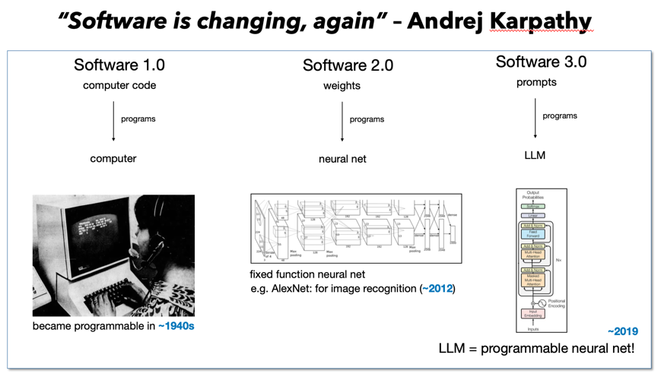
In the rest of the section I’ll use these lenses to contrast Software 1.0, 2.0, and 3.0 and show how our eval muscles get progressively weaker as we move from deterministic code to open-ended gen AI applications.

Before diving into each software “era” in turn, it’s useful to have a single view that compares them along the four dimensions we just introduced.

Dimension | Software 1.0 –  Traditional software | Software 2.0 –  ML models | Software 3.0 –  Gen AI applications / agents
What constitutes progress / an iteration? | Shipping new features and fixing bugs. Each sprint delivers code changes against a spec. | Improving model quality and latency on a well-defined prediction task (e.g., better accuracy, lower error). | Improving end-to-end agent or service quality and latency on complex, open-ended tasks (often loosely specified).
How we define and measure quality | Feature completeness, pass/fail test suites, number and severity of defects, SLIs/SLOs. | Statistical metrics: accuracy, precision/recall/F1, ROC–AUC, calibration, plus some business KPIs. Still somewhat arbitrary in how they are combined. | Composite scorecards mixing task success, “technical accuracy,” safety, UX, latency, cost, etc. Often judged by humans or LLMs and aggregated in opaque ways. Definitions are unstable and under-specified.
Who achieves and measures progress | Dev engineers build; QA / test engineers and sometimes SREs own validation and sign-off. | Data scientists / ML engineers develop and evaluate; PMs or process owners help define metrics and thresholds. | Software engineers, PMs, process owners, “prompt/agent designers” all modify behavior.  Evaluation is done by a combination of teams sometimes with unclear ownership.
Engineering processes and practices | Mature practices: version control, code review, CI/CD, test strategies, acceptance testing, change management. Clear RACI. Behavior is expected to be predictable, with no surprises. | Mix of software practices and ad hoc experiment pipelines. Model and data versioning are brittle. A/B tests and offline evals are common. RACI exists but is still evolving. | Inconsistent and emergent practices. Prompt and workflow changes can bypass normal review.  Eval pipelines and data management are ad hoc; documentation is patchy.  RACI is unclear and ownership blurred between the model provider, platform, and application team.

Software 1.0: Clear processes, and mostly predictable and understood outcomes
In “Software 1.0” the gap between what we measure and what we ship is relatively well understood. Processes are fairly predictable, work follows design, review, and approval cycles.

What constitutes progress / an iteration
In traditional software, progress is measured in terms of new features and closed defects. A sprint is successful if user stories moved to Done and the regression suite stays green. When something breaks, we can usually point at a line of code, a diff, a missing if-statement. There’s a stack trace. There’s a bug ID. There’s maybe also a person on the hook.

How we define and measure quality
Evaluation, in this world, is just an extension of specification: someone writes down what the system should do (a spec, a user story, acceptance criteria); we encode that into test cases; the system either passes or fails those tests.

Quality is measured in artifacts we’ve collectively learned to trust: percentage of tests passing, number and severity of open defects, performance, security, and so on.
This approach is not perfect: tests don’t cover everything, users do weird things, and there are always unknown unknowns. But when a release has 5 critical bugs open, everyone in the room has an intuition for what that means.
There is a shared understanding between the numbers we report and the real risk we are taking.

This is important, because it sets up a mental model that many teams still apply to AI systems: In Software 1.0 if our tests are good, a “green build” really is a strong signal.

Who achieves and measures progress
The organizational structure reinforces this clarity:
- Dev engineers write code and fix bugs.
- QA / test engineers own regression suites and sign-off.
- Sometimes SREs own production SLIs/SLOs and error budgets.

Engineering processes and practices
The engineering practices around this are mature: code review, CI/CD, version control, staging environments, change requests. Almost everything that changes behavior goes through a visible artifact and an approval cycle — a pull request, a test plan, a deployment pipeline.
We’ve spent decades building this muscle. We know how to test deterministic systems, we know how to gate releases, and we know how to have arguments about risk in terms everyone recognizes.
There is also a clear RACI around quality. Someone is explicitly accountable for saying “yes, we’re good enough” and for stopping a release when the signals look wrong.

Software 2.0: Statistical signals on shifting ground
With Software 2.0, we move from deterministic code to ML models trained from data. Let’s take the example of a model that predicts the intent or type of an HR related customer support request. Let’s assume the model is trained for ACME Inc, on ACME data.

What constitutes progress / an iteration
In Software 2.0, “progress” is usually defined as: the model got better on some metric, for some dataset.
An iteration might mean:
- trying a new model architecture,
- adding features or signals,
- tuning hyperparameters or the loss function
- collecting more data or labels,

If the offline metric goes up — accuracy from 82% to 86%, or AUC from 0.91 to 0.94 — we call that an improvement. A sprint “went well” if the new model version beats the baseline on the validation set and doesn’t blow up latency.

This is more fragile than Software 1.0, but *if* we have identified good metrics, if the dataset is “representative enough” and “large enough”, if we are careful to avoid overly reusing the test set and generally follow established “best practices”, then we are not in a bad place. Still, the relationship between that improvement and what happens in production is less certain — especially when data drifts over time.

How we define and measure quality
In principle, Software 2.0 is where we should shine: machine learning is built on statistics, the science is well established, we often have lots of data. And, it’s the right data – as we train on customer’s records. In practice, we have many knobs to turn in our eval. As a simple example, consider two models that predict the users’ intent in HR customer support requests.

One model might be broadly okay but occasionally wrong on important requests, those that we really want to get right, while the other may be worse overall but better on important requests. Yet another model might abstain more often (“I don’t know”), but be rock-solid when it does predict. Depending on whether you value coverage or safety, the “better” model changes.

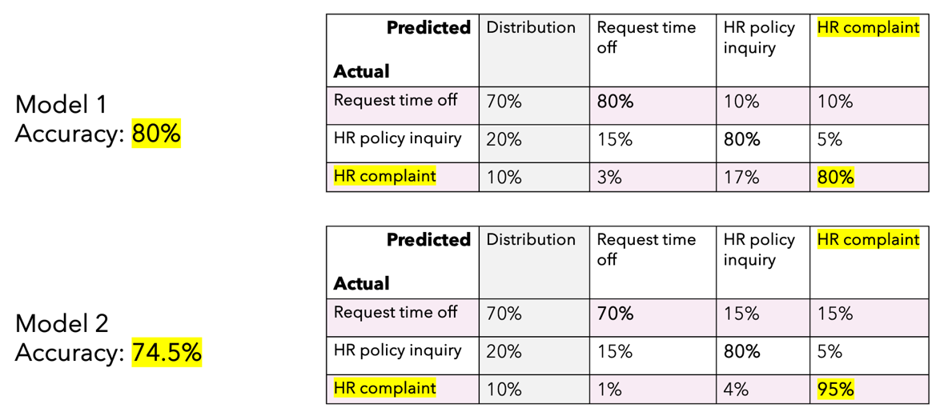

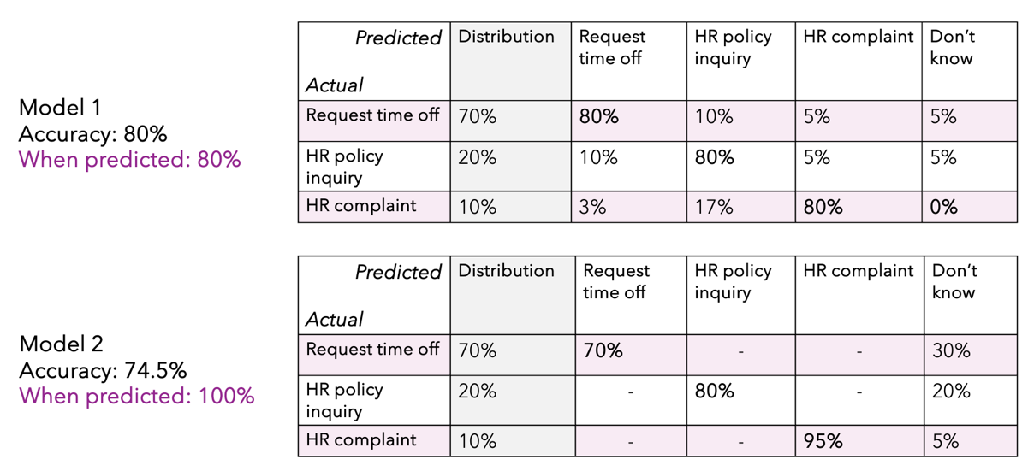

The problem extends beyond classifiers. Even for well-established functions such as search, people debate whether precision@K or recall@K is more suitable, how much to weigh the position of the link clicked… and this is of course before gen AI turned the table and added the possibility of having a direct answer to the search question rather than proposing links.

Who achieves and measures progress
An important factor in handling evaluations well is that both the progression and the assessment often involved experts in the science of experimentation.

- Data scientists / ML engineers now own a big part of both development and evaluation. They choose metrics, design experiments, and prepare the famous “model card” or scorecard.
- PMs and process owners may help define what “good” means (e.g., trade-offs between false positives and false negatives, or latency vs accuracy), but often defer to the data scientists on the details.
- Traditional QA plays a somewhat different role, getting involved mainly at the API or integration level.

Engineering processes and practices
On the process side, Software 2.0 is a hit and miss, and very much depends on the specific platform.
Vendors often reuse some Software 1.0 practices, such as version control, experiment tracking, model registries, and sometimes feature stores, offline/online evaluation pipelines. A lot still happens in notebooks, ad hoc scripts, and one-off dashboards, often lost in experimentations.
Two important consequences for evaluation:
- Versioning is brittle. It’s surprisingly easy to lose track of which data snapshot, label set, and code version produced a given metric. Reproducing an eval six months later can be non-trivial.
- Many decisions remain implicit. Sampling strategies, label guidelines, exclusion criteria, and metric definitions often live in someone’s head, or in a half-finished Confluence page. They rarely make it into the slide where we show “Accuracy: 86%.”

Sources of variability: Even in Software 2.0, before we get anywhere near gen AI, we already have multiple hidden sources of variability:
- variability from the data we sampled,
- variability from how the labels were produced (and by whom),
- variability from the choice and aggregation of metrics,
- variability from how many times we tested different variants on the same dataset
- bias resulting from multiple hypotheses testing on the same test set, and some degree of overfitting

Most teams have an intuitive sense that “eval is hard” — but few have a concrete picture of how many dimensions of randomness and bias they’re juggling.

At the same time, Software 2.0 still has important anchors:
- Tasks are usually well-defined (classification, regression, ranking).
- We often have explicit ground truth labels for at least some of the data.
- We have large datasets that are representative of what the model will see in production

Software 3.0: Gen AI Applications and the risk of Organizational Blindness

A Running Example: The Legal Proceedings Summarizer
To make the challenges of Software 3.0 concrete, let's follow a single example: an AI-powered system that summarizes legal proceedings.
A user provides a legal docket—complaints, motions, rulings, settlement documents—and the system produces a concise summary:
"2005 class action settlement resulted in Ford paying $8.55m to redesign its selection process for apprenticeship programs to address the previous process's disparate impact on Black applicants."
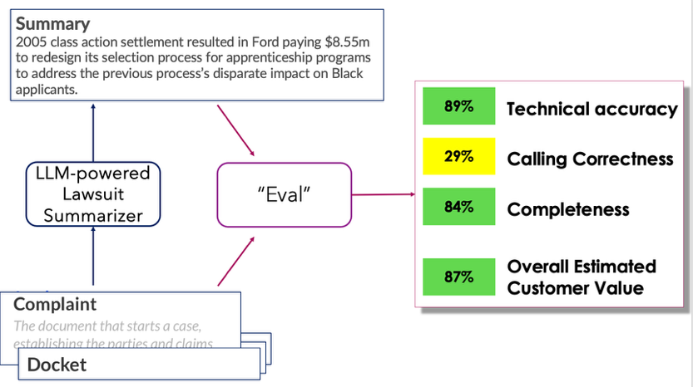
In simple cases the agents will just do a summary. In more sophisticated implementations it will connect to a variety of tools to fetch related contextual information to provide a more informed summary. We build it, run our evaluation based on company-provided guidelines for metrics, eval metrics, and eval tools, rely on a carefully curated set of 50 or 100 “ground truth” examples, and get a scorecard:
Metric | Score
Technical Accuracy | 89%
Calling Correctness | 29%
Completeness | 84%
Overall Estimated Customer Value | 87%
Let’s make a big leap of faith and assume these metrics are the ones that matter, as the problem is complex enough even with this assumption. How reliable are these numbers? Should we ask this question? And how should we act based on the answer?

Context: A Perfect Storm
Understanding organizations’ approach and response to Gen AI eval requires a reflection on the rapidity and scale of gen AI adoption – a pace unprecedented software in history.

According to McKinsey's 2025 survey, 88% of organizations now report using AI in at least one business function. The use of generative AI specifically has jumped from near-zero to 65% adoption in just two years. And this isn't experimentation anymore—38% of organizations report they are scaling or have fully scaled AI deployment across their enterprise.
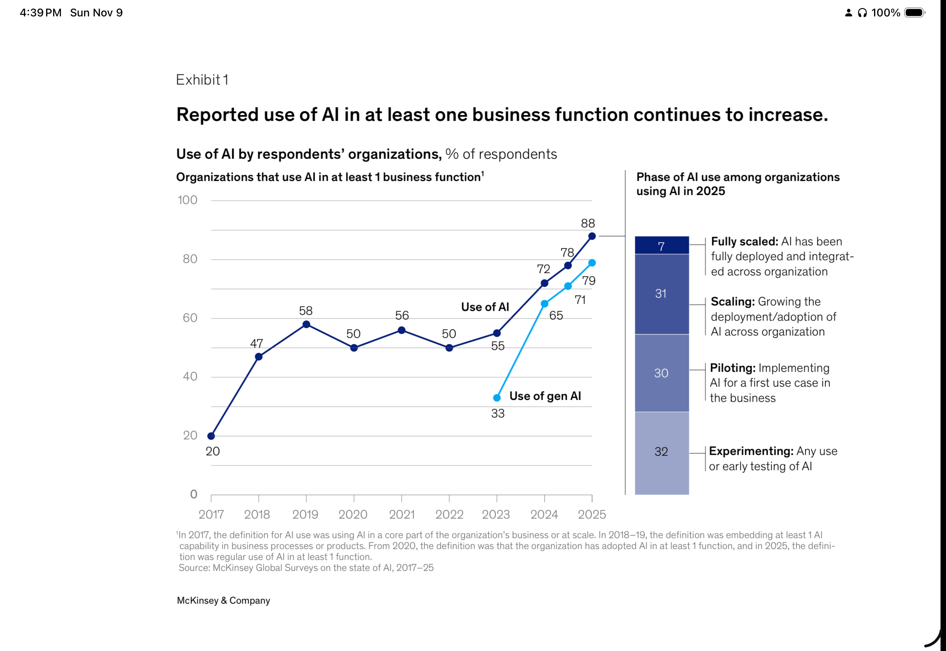

These numbers represent thousands of AI-powered features, agents, and services being built and shipped every quarter.
Several factors converge to create this situation.
- Gen AI is genuinely good.
- It applies to high-value use cases.
- It's easy to use. Almost anyone who can write a sentence can write a prompt. A product manager can prototype an AI feature in an afternoon. A business analyst can build a working demo without writing code. The barrier to entry has collapsed. Hint: this is a double-edge sword.
- CEOs have watched their kids use GPT to write essays, plan trips, debug homework problems. It works. It's impressive. It's easy. This creates a reference point: if a teenager can get useful results in minutes, surely a well-resourced engineering team can build reliable AI applications?
This reference point shapes expectations. If gen AI is this capable and this easy, then adoption should be fast, results should be good, and failures are hard to accept. "We're struggling with our AI project" sounds like an excuse when the CEO's kids built something useful over the weekend.
This creates a perfect storm for evaluation:
- High pressure to ship (the technology works, competitors are moving, executives expect results)
- High confidence in outcomes (everyone has seen it work)
- Low appreciation for the difficulty of verification (the hard part is invisible)
- Many people building, few people equipped to evaluate
The asymmetry is stark: the barrier to building gen AI applications has dropped dramatically, while the difficulty of evaluating whether they actually work has not dropped at all. If anything, it has increased.
Let’s take a moment to see why and how the problem manifests itself.

What Constitutes Progress? What's an Iteration?
In Software 3.0, progress generally means improving on the metrics we think are important. Iterations may include:
- Revise the prompt
- Switch to a different model
- Add or remove tools the agent can access
- Modify the orchestration logic
- Update the retrieval system
- Adjust the guardrails
Each of these is an iteration. Each could affect quality. Notice that since modifications are “easy”, we do tend to create a large set of variations – especially in terms of prompt.
Before discussing how we measure quality – which is the heart of the issue – lets briefly see who does so and the maturity of software development processes, so that we can better ground our conversation on quality.

Who Achieves and Measures Progress?
In Software 3.0, the set of people that builds and eval applications expands greatly. Both PMs and engineers contribute to both dev and eval. Most importantly, many people feel qualified to evaluate, even though evals are far from trivial and include many moving parts, controlled by different persons – even different teams. We may have a team of linguists generating ground truth labels, based on guidelines defined by data scientists, working over a synthetic dataset generated by another team, using a dataset generation tool crafted by yet another team. Eval can be done using a metric and a prompt recommended by yet another team,… and this is a very partial list (more to come later.
There is also an ecosystem of roles and teams that provide guidance and tools to support evaluations in some shape or form. We will get back to this later in this section.

How We Define and Measure Quality
This is the heart of the problem. Let’s see different approaches and reflect on them.

First idea: Vibe evals.
In the “beginning”, at the onset of GPT 3.5, quality was often assessed by companies using “vibe evals”. This was popular until two things happened:
First, teams started “overfitting to the CTO”. You had the CTO doing vibe evals, teams logging the CTO test prompts, and adding those tests (with the answers believed to be what the CTO expected) as examples (in-context learning). This generated a manifest difference between expected and actual quality in prod.
Second, PMs generally started requesting that eval become more systematic.
This does not mean that vibe eval has been abandoned: I believe it is the primary method of eval by developers when iterating over a solution, even today, mainly to pick the version that undergoes a more “structured” evaluation.

Next idea: metrics and golden datasets
The approach: define metrics (e.g., technical accuracy, completeness, correctness), hand-curate a dataset of test cases with ground truth, measure systematically. This produces scorecards. Numbers. Dashboards. It feels rigorous.

But let's look at what these numbers actually tell us – and what they don’t.
To “demonstrate” that
- that there is a large uncertainty in evals and
- That this is more than we think,
I’ll proceed with a few examples. I will also show which solutions do not work (and can, in fact, backfire), and why. Then, we’ll see if we can instead try to make some progress.

Sources of Biases and Uncertainty – and their Impact

Uncertainty due to data size
You run your evaluation on 100 test cases and get 82%. How confident should you be in that number?
First of all, ask yourself the question: Do you know? Do you think the people reporting on the eval know? Do you think the team listening to the presentation know?
You may know. But my experience is that even among attendees of scientific conferences, most people don’t know. I guarantee that the average listener of reports on AI eval in companies does not know. The answer, by the way, is nuanced, and somewhat depends on assumptions and on the “mean” accuracy, but a ballpark estimate is that with 100 data points at a mean accuracy of 82%, the 95% confidence interval is roughly 16 points wide. The true accuracy could plausibly be anywhere from 74% to 90%.
And this is enough to flip your decisions.
Just to be clear: the interval is ONLY 16 points wide if you make a lot of optimistic and likely unrealistic assumptions, that we can sum up as “the only source of uncertainty is the sample size”. That’s never the case. We will see more as we go.
This begins to show that the report may not just be meaningless, but also misleading. And if as listener we do not ask questions, we are contributing to a culture that fosters random iterations in search for a good solutions.
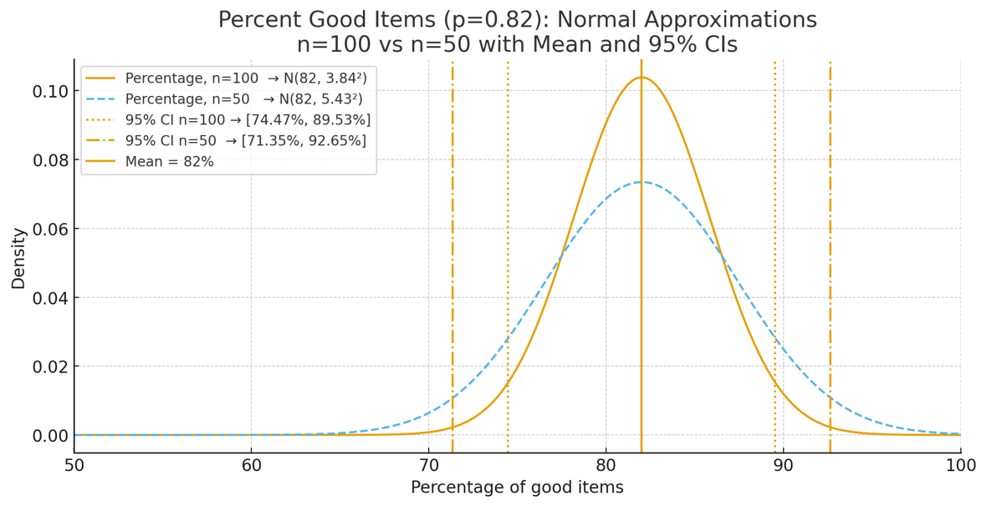

Bias and Uncertainty due to Multiple Hypotheses testing
In Software 3.0, improvement is usually not a single leap, but a search process. You try a prompt tweak. You change the retrieval strategy. You reorder steps in the pipeline. You swap the judge prompt. You run the same evaluation suite again. Repeat.
This is a healthy engineering loop. But it changes what an evaluation score means. The moment we run many variants and report (or remember) the best-looking number, we have quietly introduced a statistical phenomenon that is both simple and surprisingly strong: multiple hypothesis testing.
Here, a "hypothesis" is not a formal paper claim. It is any variant we tried: a prompt version, a pipeline branch, a scoring rule, a filtering threshold, or even a different way to aggregate sub-metrics. Testing many hypotheses is not the problem. The problem is that selection ("pick the winner") converts random noise into systematic optimism.
A quick analogy: if you roll one fair die, the expected value is 3.5. If you roll 20 fair dice and keep the highest, the expected value is much higher - even though nothing about the dice improved. In evaluation, the "dice" are the random components of measurement: finite sample size, ambiguous ground truth, judge variability, and the many small implementation choices that leak into scores. The best score among many tries is expected to be "lucky".
A simple model: "best-of-K" scores are biased upward
Let the observed score for variant i be a noisy estimate of its underlying performance on the evaluation distribution:
observed_score_i = true_score_i + noise_i
Assume the noise terms are centered (the evaluation is not systematically biased in one direction for any single run), with standard deviation σ. This σ is a summary of all the uncertainty we discussed earlier: sampling noise, scoring choices, judge prompt sensitivity, and so on.
Now consider the simplest case where all variants are equally good (true_score_i = true_score for all i). If we run K variants and select the highest observed score, we get:
selected_score = true_score + max(noise_1, ..., noise_K)
Even though each noise_i has mean 0, the maximum does not. The expected max is positive, so the selected score is systematically optimistic. This is the "winner's bonus" (also called the winner's curse in other domains).
Table D1. Expected "winner's bonus" from selecting the best of K tries
K variants tried | E[max noise] / σ | 10th-90th percentile  (range) in σ units | If σ = 4 points,  expected bonus
1 | 0.000 | -1.28 to 1.28 | +0.0 points
2 | 0.564 | -0.48 to 1.63 | +2.3 points
3 | 0.846 | -0.09 to 1.82 | +3.4 points
5 | 1.163 | 0.33 to 2.04 | +4.7 points
10 | 1.539 | 0.82 to 2.31 | +6.2 points
20 | 1.867 | 1.23 to 2.56 | +7.5 points
50 | 2.249 | 1.70 to 2.86 | +9.0 points
Two things are worth noticing in Table D1.
First, the effect grows quickly. By the time you have tried 10-20 variants, the expected winner's bonus is already around 1.5-1.9σ. That is not a rounding error if σ is several points.
Second, the winner's bonus is itself variable. Sometimes the best-of-K result is only slightly lucky; sometimes it is very lucky (for K=20, the 90th percentile is around 2.6σ). This is why a single "best" number can feel unstable across runs and across weeks of iteration.
Concrete example: what 5 vs 10 vs 20 variants means in percentage points
To translate σ into something tangible, it helps to connect it to test-set size. If your metric is a simple accuracy-like fraction (pass/fail on N cases), then even a perfectly deterministic system has sampling noise: different samples of N cases would yield slightly different scores.
For illustration, suppose the underlying accuracy is about 80%. The standard deviation of the measured accuracy from N cases is approximately sqrt(p(1-p)/N), and the familiar 95% interval is about ±1.96σ. Table D2 turns that into expected best-of-K inflation for K = 5, 10, 20.
Table D2. From test-set size to measurement noise to best-of-K inflation (illustrative p = 0.8)
N test cases | σ (points) | Approx 95%  half-width | Best-of-5  (+ points) | Best-of-10  (+ points) | Best-of-20  (+ points)
50 | 5.66 | ±11.1 | +6.6 | +8.7 | +10.6
100 | 4.00 | ±7.8 | +4.7 | +6.2 | +7.5
200 | 2.83 | ±5.5 | +3.3 | +4.4 | +5.3
500 | 1.79 | ±3.5 | +2.1 | +2.8 | +3.3
1000 | 1.26 | ±2.5 | +1.5 | +1.9 | +2.4
Read Table D2 as a "reality check" for seemingly precise score improvements. With N = 100 cases, the sampling-only σ is about 4 points, so best-of-20 inflation is about +7.5 points on average. With N = 200, it drops to about +5.3 points. With N = 1000, it is still around +2.4 points.
And this is only sampling noise. In Software 3.0, the effective σ is often larger because the evaluation pipeline itself is stochastic or under-specified: judge prompts, scoring maps, borderline cases, and label disagreement all contribute additional variance. Selection does not care where σ comes from - it will amplify whatever noise is present.
How different were your variants? Correlation reduces the effect, but does not remove it
A reasonable objection is: "But my variants are not independent. Prompt v17 and prompt v18 are almost the same." That's right - and it matters.
If two variants tend to succeed and fail on the same items, their score fluctuations are correlated. In the extreme case of perfectly correlated variants (they behave identically on every test case), trying more variants adds no additional winner's bonus because there is no additional randomness to exploit.
Most real workflows sit in between: variants are partially correlated. Table D3 uses a simple equicorrelation model (every pair has correlation ρ) to show how the expected winner's bonus shrinks as variants become more similar.
Table D3. Expected winner's bonus in σ units under correlated variants (simulation, equicorrelation ρ)
Correlation ρ  between variants | Best-of-5  E[max]/σ | Best-of-10  E[max]/σ | Best-of-20  E[max]/σ
0.00 | 1.16 | 1.54 | 1.87
0.25 | 1.01 | 1.33 | 1.61
0.50 | 0.82 | 1.09 | 1.32
0.75 | 0.58 | 0.77 | 0.93
0.90 | 0.37 | 0.49 | 0.59
The key takeaway is not the exact ρ value - it is the concept of an "effective number of independent tries." If your search is wide (materially different pipeline branches, different prompt families, different judge setups), the effective K can be close to the literal K. If your search is narrow (tiny edits to a single prompt), the effective K is smaller. Either way, selection still adds optimism; the only question is how much.
Why this creates the illusion of progress: spurious "wins" become likely
A different way to see the same phenomenon is to ask: if none of the variants are truly better, how often will the best one still look meaningfully better?
Assume σ = 4 points (roughly what N = 100 cases gives you for an 80% metric, even before judge variability). Table D4 shows the probability that best-of-K will exceed the true score by at least δ points purely due to noise.
Table D4. Probability that best-of-K looks at least δ points better than truth (σ = 4 points, independent case)
Threshold δ  (points) | Best-of-5  P(max > δ) | Best-of-10  P(max > δ) | Best-of-20  P(max > δ)
2 | 84.2% | 97.5% | 99.9%
4 | 57.8% | 82.2% | 96.8%
6 | 29.2% | 49.9% | 74.9%
8 | 10.9% | 20.6% | 36.9%
Table D4 explains a common experience in prompt engineering: you can "find" a 4-8 point improvement surprisingly easily when the test set is small and you iterate a lot - even if the underlying system has not improved. The more variants you try, the more inevitable it becomes that at least one will look great on the particular items in your evaluation suite.
None of this means iteration is bad. It means the metric is doing two jobs at once: (1) measuring, and (2) guiding search. Once you recognize that, you gain a useful superpower: you can interpret a reported score as "best-of-K under noise" rather than as a single, unbiased measurement.
When you see a crisp green number, three context questions often unlock most of the uncertainty:
• How many variants (prompts / pipeline branches / thresholds / judge setups) were tried and compared on this same dataset?
• How noisy is one evaluation run (what is σ, or what would repeated runs / resamples look like)?
• How wide was the search (were variants meaningfully different, or minor edits to the same underlying behavior)?
Those questions do not prevent progress - they help you interpret progress. And they help you avoid mistaking a lucky winner for a durable improvement.
Each of these adds variance. Each can introduce bias. And each is sufficient to flip your decisions—about what to ship, and about which direction to iterate.

If you are comparing two prompt variations. System A scores 79%, system B scores 85%. You pick B and move forward. But with ±8 points of variance on each measurement, system A might actually be better. With a 30-40 points interval, it’s a randomizer. You just iterated in the wrong direction—and you have no way of knowing, unless after 4 months into production.
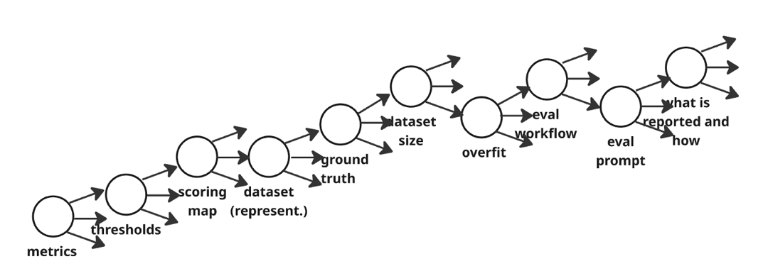

Bias and uncertainty due to developer-induced overfit

Note: This section focuses specifically on bias introduced when developers tune prompts based on observing test cases. Related issues—statistical uncertainty from small sample sizes and bias from multiple hypothesis testing—are discussed in separate sections. Here we isolate the overfitting mechanism to clarify its distinct contribution to the gap between test and production performance.

The Mechanism: A Different Kind of Overfitting
Classical overfitting occurs when a model with too much capacity memorizes training data rather than learning generalizable patterns. What we observe in Gen AI evaluation is structurally different: the developer becomes the fitting agent, not the model.
Consider how prompt engineering typically works. A team builds an AI agent—say, a tool-calling agent for IT support. They create 50 or 100 test cases. They run the agent, observe failures, and iterate. They adjust the prompt, add in-context examples, tweak instructions. Test accuracy improves from 65% to 88%.
What happened during this process? The developer—consciously or not—learned the patterns in those specific test cases. Their intuitions about "what makes a good prompt" became shaped by those 50 examples. The in-context examples they added were chosen because they helped with the failures they observed. The instructions they refined were tuned to handle the specific ambiguities present in their test set.
This is not a failure of engineering discipline. This is normal, reasonable engineering behavior. When you see a failure, you fix it. When you see a pattern, you encode it. The challenge is structural: this process changes the relationship between your test score and your production performance in ways that are difficult to detect.

The Nuance: When This is Good Engineering vs. Problematic Overfitting
Before examining the risks, we should acknowledge an important nuance: tuning to observed patterns can be entirely legitimate.
Suppose a developer examines test cases and notices that users frequently ask about PTO using broken English, abbreviations, and typos. They add in-context examples that handle these variations. Test accuracy improves. Is this problematic?
If the test set is representative of production—if production users also frequently use broken English, abbreviations, and typos—then this is good engineering. The developer identified a real pattern and addressed it.
The problem arises when the test set is not representative. If the test set over-represents certain patterns, under-represents others, or happens to contain spurious correlations, then each "improvement" potentially increases the gap between test and production performance. The developer is fitting to the idiosyncrasies of the sample rather than to the true distribution.
The difficult part: these two scenarios look identical from the developer's perspective. The same test-set improvement—say, from 70% to 88%—could represent:
- Legitimate improvement that will fully transfer to production
- Partial improvement (perhaps 10 points real, 8 points overfitting)
- Overfitting that will not transfer to production
The test score alone cannot distinguish between these cases. Only held-out data or production results can reveal which occurred.

Example A: Lexical Overfitting
The Setup
A team builds a password-reset agent. Their golden dataset of 100 test cases was curated by a QA team who wrote clear, well-formed queries:
Test Set Examples (Clean Phrasing)
"I need to reset my password"
"Forgot my credentials for the VPN"
"Password reset request for SAP"
"I can't remember my login credentials"
The team iterates on the prompt, adding in-context examples that match this style. Test accuracy reaches 94%.
The Gap
Production users don't write like QA teams:
Production Examples (Messy Phrasing)
"cant log in keeps saying wrong password tried 3 times now HELP"
"locked out again ffs"
"the thing says my password is wrong but its not???"
"¿cómo cambio mi contraseña?"
Distribution Comparison
Phrasing Type | Test Set | Production
Clean phrasing | 100% | 35%
Messy phrasing | 0% | 65%
Agent Accuracy by Phrasing Type
Phrasing Type | Agent Accuracy
Clean phrasing | 94%
Messy phrasing | 71%
Results Summary
Metric | Value
Test Accuracy | 94.0%
Production Accuracy | (0.35 × 94%) + (0.65 × 71%) = 79.1%
Bias (Test − Production) | 14.9 percentage points
The test score overestimates production performance by nearly 15 points. This gap emerged not because the agent is poorly designed, but because the prompt engineering optimized for lexical patterns that don't fully match production.
Variance in Overfitting Across Teams
Beyond the bias itself, there is variance in how much different teams overfit. This is distinct from statistical sampling variance (discussed elsewhere). Here, the variance arises because different teams, even working on similar problems, will:
- Curate slightly different test cases
- Observe different failure patterns
- Make different tuning decisions in response
The result: teams with comparable underlying agent quality may report quite different test scores, depending on how their particular test set shaped their tuning.
Metric | Estimate
Average overfitting bias across teams | ~12 points
Range of overfitting bias | 5 to 20 points

Example B: Distribution Mismatch in Tool Selection
The Setup
An IT support agent can invoke five tools: KB Search, Ticket Creator, Password Reset, Network Diagnostics, and Escalation. The team curates 80 test cases covering all five.
Curation is challenging. Password reset cases are easy to write (clear intent, obvious correct tool). Network diagnostic cases are complex (ambiguous symptoms, multiple possible tools).
Distribution Comparison
Tool | Test Set Distribution | Production Distribution
Password Reset | 31% (25 cases) | 15%
KB Search | 28% (22 cases) | 20%
Ticket Creator | 22% (18 cases) | 15%
Network Diagnostics | 12% (10 cases) | 35%
Escalation | 6% (5 cases) | 15%
The team adds in-context examples roughly proportional to their test distribution.
Agent Accuracy by Tool
Tool | Agent Accuracy
Password Reset | 93%
KB Search | 89%
Ticket Creator | 85%
Network Diagnostics | 72%
Escalation | 68%
Note: Tools that are under-represented in the test set have lower accuracy—the developer had fewer failure examples to learn from and tune against.
Accuracy Calculation
Calculation | Formula | Result
Test Accuracy | (0.31 × 93%) + (0.28 × 89%) + (0.22 × 85%) + (0.12 × 72%) + (0.06 × 68%) | 86.5%
Production Accuracy | (0.15 × 93%) + (0.20 × 89%) + (0.15 × 85%) + (0.35 × 72%) + (0.15 × 68%) | 78.6%
Results Summary
Metric | Value
Test Accuracy | 86.5%
Production Accuracy | 78.6%
Bias (Test − Production) | 7.9 percentage points
This gap arises from distribution mismatch amplified by tuning. The developer naturally spent more effort on the cases they saw most often. If the under-represented tools are also the harder ones (which is often why they're under-represented—they're harder to write good test cases for), the gap widens further.

Example C: Complexity Mismatch
The Setup
Test cases were written by humans creating "good examples." Unconsciously, they created clean, single-intent, unambiguous queries:
Test Set Examples (Clean, Single-Intent)
"Create a ticket for the printer on floor 3 not working"
"What is the policy for expense reimbursement over $500?"
"Reset password for user jsmith@company.com"
The team tunes the agent to these. Test accuracy: 91%.
The Gap
Production queries are messier:
Production Examples (Complex, Ambiguous)
"the printer on 3 is broken again and also can you check why my vpn keeps disconnecting and btw I never got reimbursed for that trip last month"
"so I tried what the other agent said but now something else is wrong, see attached screenshot" [no screenshot attached]
"following up on this" [no context provided]
Distribution Comparison
Query Complexity | Test Set | Production
Clean, single-intent | 100% | 25%
Messy but parseable | 0% | 45%
Genuinely ambiguous | 0% | 30%
Agent Accuracy by Complexity
Query Complexity | Agent Accuracy
Clean, single-intent | 91%
Messy but parseable | 74%
Genuinely ambiguous | 52%
Accuracy Calculation
Calculation | Formula | Result
Test Accuracy | 100% clean queries at 91% | 91.0%
Production Accuracy | (0.25 × 91%) + (0.45 × 74%) + (0.30 × 52%) | 71.7%
Results Summary
Metric | Value
Test Accuracy | 91.0%
Production Accuracy | 71.7%
Bias (Test − Production) | 19.3 percentage points
This nearly 20-point gap emerges because the test set systematically underrepresents the complexity of production queries. The developer never saw messy multi-intent queries, so they never tuned for them.

Example D: Spurious Correlation in Tool Selection
The Setup
An IT support agent can invoke a "Next Best Action" (NBA) tool that uses case history to recommend solutions, or a "KB Search" tool that searches documentation. The initial prompt is simple: "retrieve information to solve the user's request."
Observing test cases, the developer notices a pattern: when a case already has diagnostic information attached, the NBA tool produces better results than KB Search. This seems reasonable—NBA can use that diagnostic context. The developer adds instructions: "When prior diagnostics are present, prefer the Next Best Action tool."
Before and After Tuning
Metric | Before Tuning | After Tuning
Test Accuracy | 78% | 86%
The Gap
The developer learned a spurious correlation. In the test set, cases with prior diagnostics happened to be predominantly network issues (because the IT team ran diagnostics on network problems before escalating). NBA happens to be excellent at network issues specifically—not "cases with diagnostics" generally.
Test Set vs. Production: Cases with Diagnostics
Case Type (with diagnostics) | Test Set | Production
Network issues | ~80% | 30%
Hardware issues | ~10% | 40%
Software/Access issues | ~10% | 30%
Agent Accuracy on Diagnostic Cases in Production
Case Type | % of Diagnostic Cases | NBA Accuracy | Better Tool
Network | 30% | 89% | NBA
Hardware | 40% | 61% | KB Search
Software/Access | 30% | 70% | Mixed
Accuracy Calculation for Diagnostic Cases
Calculation | Formula | Result
Test Accuracy (diagnostic cases) | ~88% (diagnostics ≈ network in test set) | 88%
Production Accuracy (diagnostic cases) | (0.30 × 89%) + (0.40 × 61%) + (0.30 × 70%) | 72.1%
Results Summary
Metric | Value
Test Accuracy (diagnostic cases) | 88.0%
Production Accuracy (diagnostic cases) | 72.1%
Bias (Test − Production) | 15.9 percentage points
The rule "diagnostics → NBA" was actually proxying for "network issues → NBA" via a feature that doesn't generalize. The developer made a reasonable inference from the data they observed—but that inference encoded a spurious correlation.

Summary: The Compounding Effect
These biases don't exist in isolation. A real agent might experience all four:
Summary of Overfitting Bias by Type
Overfitting Type | Mechanism | Bias Introduced
Lexical overfitting | Test cases use phrasing that differs from production | 14.9 points
Distribution mismatch | Some tools/intents over-represented in test set | 7.9 points
Complexity mismatch | Test cases are cleaner than production queries | 19.3 points
Spurious correlation | Pattern in test set doesn't hold in production | 15.9 points
Compounded Effect
When multiple overfitting mechanisms operate together, their effects partially overlap but also partially compound:
Scenario | Test Accuracy | Possible Production Accuracy
Single bias source | 88% | 73–80%
Multiple bias sources (partial overlap) | 88% | 60–78%
Variance in Overfitting Across Teams
Different teams working on similar problems will overfit differently, based on their specific test cases and tuning decisions. This creates variance in reported metrics that reflects evaluation artifacts rather than true capability differences:
Metric | Value
Team A reported accuracy | 84%
Team B reported accuracy | 91%
Potential difference due to overfitting artifacts | Up to 7 points
When leadership compares teams or use cases based on reported metrics, some portion of the apparent differences may reflect how each team's test set shaped their tuning, rather than true capability differences.

The Observability Challenge
The core difficulty is epistemological. The developer who has tuned to their test set cannot easily determine whether they've improved generalization or merely improved test-set performance.
What Makes the Overfitting Gap Visible
Method | Description
Held-out test set | A set that no developer has seen or tuned to
Production data | The ultimate held-out set
Independent evaluation | A different team evaluating with fresh data
Without one of these, the overfitting gap between test and production performance remains hidden. The developer reasonably believes the agent has improved—every signal available to them confirms this.
Why the "Mythical 100" Amplifies Overfitting
The common practice of using a small golden dataset (often 50–100 examples) for both development iteration and final evaluation creates a structural problem for overfitting specifically:
Factor | How It Amplifies Overfitting
Developers see all test cases | Every failure becomes a tuning target
Multiple iteration rounds | Each round fits more tightly to the specific sample
No held-out partition | No way to detect when tuning stops generalizing
Note: Small sample sizes also introduce statistical uncertainty (roughly ±8 points at 80% accuracy with n=100), which is a separate issue discussed in the section on sample size effects. Here, the point is different: even if we had perfect statistical precision, the overfitting bias would remain. The 100 samples that have been used for multiple rounds of iteration no longer provide an unbiased estimate of production performance—they increasingly reflect the tuning decisions made against them.
The result is that test accuracy becomes a measure of "how well did we tune to these specific 100 cases" rather than "how well will the agent perform in production."

Qualitative to Quantitative Eval Mapping
Even when we have collected our data, run our evaluations, and obtained raw results from our LLM-as-judge or human raters, we are not done making consequential choices. We still have to map those results to scores—and this mapping is far more arbitrary than most teams realize.
Let me make this concrete. Suppose we use a prompt that judges "completeness" on a qualitative 1-3 scale:
- 1 = incomplete
- 2 = partially complete
- 3 = fully complete

This is a reasonable approach. But now we need to report a score to stakeholders. So, we convert it to a percentage using a simple linear mapping:
agg_score = (3 × count_3s + 2 × count_2s + count_1s) / total_count
completeness_score = 100 × (agg_score - 1) / (3 - 1)
The result: 84% Completeness. Green box.

That linear mapping encodes an assumption—that the difference between a 1 and a 2 is the same as the difference between a 2 and a 3. Is that true? It depends entirely on what you care about. Consider three systems, each evaluated on 10 samples:

System | Count of 3s | Count of 2s | Count of 1s | Characterization
A | 4 | 4 | 2 | Mixed performance, some excellence
B | 2 | 8 | 0 | Consistent, no failures
C | 6 | 0 | 4 | Bimodal: great or terrible
Under our linear mapping, all three systems score exactly the same: 2.2 average, or 60%.
But these systems are radically different. System B never fails but rarely excels. System C is either brilliant or terrible, with nothing in between. System A is somewhere in the middle. Which would you rather deploy?

Five Reasonable Mappings, Five Different Winners
To illustrate how much this matters, here are five defensible ways to map a 1-3 scale to a 0-100 score:
Mapping | Rationale | Score Values | Results | Winner
Linear | Equal intervals | 1→0, 2→50, 3→100 | A=60, B=60, C=60 | TIE
Top-Heavy | "2 is barely acceptable; 3 is true excellence" | 1→0, 2→30, 3→100 | A=52, B=44, C=60 | C
Mid-Heavy | "2 is already quite good; don't penalize moderate performance" | 1→0, 2→70, 3→100 | A=68, B=76, C=60 | B
Quadratic | Capability grows with squared effort | 1→0, 2→44, 3→100 | A=58, B=56, C=60 | C
Exponential | Each level represents exponentially more capability | 1→0, 2→25, 3→100 | A=50, B=40, C=60 | C

Same raw data. Five different answers to "which system is best."
And note: every one of these mappings is reasonable. The choice between them is a value judgment about what matters—but it's a value judgment that is almost never made explicitly. What may happen is that someone writes a linear mapping because it's the simplest default, and that implicit choice propagates through to iterations and ship/no-ship decisions without anyone realizing a choice was made at all.
This is a microcosm of the larger problem. Throughout the evaluation pipeline, we make choices that feel technical but are actually normative:
- How do we weight different error types?
- What threshold makes something "good enough"?
- How do we aggregate across heterogeneous metrics?
Each choice embeds a judgment about what we value. When these choices are made explicitly, with stakeholder input, they become defensible decisions. When they're made implicitly, by an engineer writing a scoring function at 11pm, they become hidden assumptions that can silently determine whether we ship the right system or the wrong one.
The solution is not to find the "correct" mapping—there often isn't one. The solution – or part of a solution anyways - is to make the choice visible, explicit, intentional, maybe even motivated: document why you chose a particular mapping, show stakeholders what would change under alternative mappings, and ensure that the people accountable for the product understand the value judgments embedded in the score they're approving.

Impact of noisy ground truth, noisy LLM judge, or Subjectivity
Most evaluation pipelines for Software 3.0 quietly assume something that feels 'Software 1.0-ish':
- There is a correct answer (ground truth), or
- There is a stable judge (human or LLM) who can reliably say whether the output is 'good,' 'accurate,' 'complete,' etc.
In gen AI products, both assumptions often fail - not because teams are sloppy, but because the object being measured is different.
A legal proceedings summarizer is a good example. Two summaries can both be defensible while emphasizing different facts, different levels of caution, different structure, or different 'what matters' to the reader. Even 'technical accuracy' can be tricky: do we penalize missing a nuance? Is a hedged statement 'accurate' if it avoids claiming what is not proven? Is it 'complete' if it omits a detail that the user did not care about?
This section is about a specific kind of uncertainty: uncertainty caused by the judging process itself, whether that judging is called 'ground truth,' 'human evaluation,' or 'LLM-as-judge'.
To keep the discussion concrete, it helps to separate three phenomena that are often conflated:
- Noisy ground truth: the labels / reference answers are imperfect.
- Noisy judge: the rater (human or LLM) is inconsistent or error-prone relative to the intended criterion.
- Subjectivity: there may not be a single intended criterion; different users legitimately disagree.
The punchline is subtle but important: in Software 3.0, noise in judging does not merely add a bit of variance around a stable metric - it can change what the metric means, compress apparent progress, and create large variance in perceived quality across users.

A simple model: 'true quality' is latent, judgments are noisy measurements
Assume each test case ultimately has a latent 'would a typical user accept this?' variable:
- Let T = 1 mean the output is acceptable to the target user population (for the metric we care about).
- Let T = 0 mean it is not.
Let p = P(T = 1) be the probability that a random test case is truly acceptable.
Now introduce a judge (human rater, LLM judge prompt, etc.) that produces an observed label Y in {0, 1}. Two error rates matter:
- False negative rate beta = P(Y=0 | T=1) (judge rejects good outputs).
- False positive rate alpha = P(Y=1 | T=0) (judge accepts bad outputs).
Then the observed pass rate reported by the eval is:
q = P(Y=1) = p*(1 - beta) + (1 - p)*alpha
This equation is the entire story. Everything else is consequences:
- If alpha and beta are nonzero, the metric is not just noisy; it can be systematically shifted.
- If alpha and beta drift over time (model update, prompt tweak, rubric change), your reported score can shift even when your system did not.
A common simplifying case is symmetric noise, where the judge flips a label with probability e in either direction (alpha = beta = e). Then:
q = p*(1 - e) + (1 - p)*e = p*(1 - 2e) + e
This has a striking implication: noise pushes scores toward 50% and shrinks differences between systems.

What judge noise does to reported scores (and why it is not a small effect)
Table 5.5-A shows what happens to a 'true' quality level p when the judge has symmetric error rate e.
Table 5.5-A. Symmetric judge error pushes scores toward 50% (compression effect)
(True pass rate p is what the target users would think; Observed is what the noisy judge reports.)
True pass rate p | Observed if e=0% | Observed if e=5% | Observed if e=10% | Observed if e=20% | Observed if e=30%
60% | 60% | 59% | 58% | 56% | 54%
70% | 70% | 68% | 66% | 62% | 58%
80% | 80% | 77% | 74% | 68% | 62%
90% | 90% | 86% | 82% | 74% | 66%
Read that carefully. If the true user-approval rate is 80%, a judge that is 'only' 10% wrong on individual cases will report about 74%. A judge that is 20% wrong will report about 68%.
This is why judge noise is not just an academic detail. It is numerically large enough to flip ship/no-ship decisions.
Now look at what it does to comparisons, which are the backbone of iteration. If System B is truly better than System A by Delta points, then with symmetric judge noise:
observed Delta = (1 - 2e) * true Delta
Table 5.5-B shows how judge noise shrinks apparent improvements.
Table 5.5-B. Judge noise shrinks apparent improvements (progress looks smaller than it is)
Judge error e | Shrink factor (1-2e) | If true Delta = 5 pts | If true Delta = 10 pts
0% | 1.00 | 5.0 pts | 10.0 pts
5% | 0.90 | 4.5 pts | 9.0 pts
10% | 0.80 | 4.0 pts | 8.0 pts
20% | 0.60 | 3.0 pts | 6.0 pts
30% | 0.40 | 2.0 pts | 4.0 pts
This is a deeply Software 3.0 phenomenon: teams iterate, make real improvements, and the measurement device compresses those improvements. The team experiences 'we cannot move the metric' and starts searching more aggressively (more prompt variants, more pipeline complexity, more scoring hacks), which can increase multiple-hypothesis pressure.
Judge noise can create a feeling of slow progress, which increases iteration intensity, which increases selection bias, which increases confidence in lucky winners.

Noise does not just bias the mean; it reduces your 'effective sample size'
Even if you know (or suspect) your judge error rate e, you might try to correct the observed score:
p_hat = (q_hat - e) / (1 - 2e) [symmetric noise case]
But the correction comes with a cost: uncertainty gets amplified. In the symmetric-noise case, the information about p is reduced by a factor of:
(1 - 2e)^2
A useful interpretation: if your judge has error rate e, then evaluating N items gives you about as much information as evaluating:
N_eff = N * (1 - 2e)^2
Table 5.5-C shows what this means in practice.
Table 5.5-C. Judge noise reduces the effective N (how much your dataset 'counts')
Judge error e | Information factor (1-2e)^2 | Effective N if N=100
0% | 1.00 | 100
5% | 0.81 | 81
10% | 0.64 | 64
20% | 0.36 | 36
30% | 0.16 | 16
This is a helpful mental move because it connects directly to sample-size intuition: a noisy judge can quietly turn a '100-case eval' into something that behaves like a 36-case eval in terms of how precisely you can estimate true user-perceived quality.

Noisy ground truth: when your labels are uncertain, the metric has a ceiling
So far we treated T as 'what users would believe' and Y as 'judge output'. But many organizations treat Y as 'ground truth'. That works well in Software 2.0 classification tasks when labels are well-defined and inter-annotator agreement is high.
In gen AI tasks, a big fraction of your 'ground truth' is actually: one person (or one rubric) calling it one way.
A simple way to see the impact is to imagine that the ground truth label is produced by a human expert who is correct with probability (1-e) relative to the intended criterion. Then even a perfect system will score about (1-e) against that ground truth.
But we usually do not know e directly. What we often see is disagreement between labelers.
Under a simplified symmetric model where two equally-skilled judges make independent errors with rate e, their disagreement rate D is:
D = 2e*(1 - e)
Solving for e (the smaller root):
e = (1 - sqrt(1 - 2D)) / 2
Table 5.5-D translates disagreement into a rough scale for reliability (under that simplified model).
Table 5.5-D. What rater disagreement implies about rater reliability (simplified model)
Disagreement between two judges (D) | Implied per-judge error e | Implied reliability (1-e)
10% | 5.3% | 94.7%
20% | 11.3% | 88.7%
30% | 18.4% | 81.6%
40% | 27.6% | 72.4%
Two important caveats: this model assumes there is a truth and disagreement is error; and in subjective domains, disagreement is not a defect but a property of the task.
Even with those caveats, Table 5.5-D gives a practical superpower: it translates 'we disagree a lot' into a rough magnitude. If your metric has 30-40% disagreement between competent raters, then treating one rater's label as 'ground truth' creates a measurement instrument whose reliability is closer to about 70-80% than to 95-99%.

Noisy LLM judge: inconsistency creates run-to-run variance even on the same dataset
So far, judge noise was modeled as error relative to truth. There is another kind of noise that matters a lot for LLM judges: the judge can be inconsistent even when you re-judge the same output.
LLM judges can flip decisions due to borderline cases and underspecified rubrics, differences in reasoning paths, small prompt/context changes, long context effects across a batch, and calibration quirks.
A simple model: for each item j, the LLM judge says 'pass' with probability q_j. If many items are borderline (q_j near 0.5), then the overall evaluation score will have high run-to-run variance.
Table 5.5-E illustrates this while holding the expected score near 80% and changing how many cases are borderline.
Table 5.5-E. Same average score, very different run-to-run variance (stochastic judge)
(Assume N=100 items; 'clear' items are judged pass with prob 0.95 or 0.05; borderline items with prob 0.5.)
Borderline items (q=0.5) | Clear pass items (q=0.95) | Clear fail items (q=0.05) | Expected score | Run-to-run SD (single eval) | Approx 95% band
0 | 83 | 17 | 79.7% | 2.2 pts | ±4.3 pts
10 | 78 | 12 | 79.7% | 2.6 pts | ±5.1 pts
20 | 73 | 7 | 79.7% | 3.0 pts | ±5.8 pts
30 | 68 | 2 | 79.7% | 3.3 pts | ±6.4 pts
33 | 67 | 0 | 80.2% | 3.4 pts | ±6.6 pts
Two teams can both report 'about 80%', but one may sit on a metric that wobbles by about ±4 points run-to-run, while another wobbles by about ±7 points, solely because their dataset contains a different share of borderline cases and their judge is inconsistent on those.
This is also why 'rerun the eval to verify' is not always reassuring: rerunning can legitimately produce a different number without any system change.

Subjectivity: user perception is a distribution, not a point estimate
Sometimes even defining T as a single truth is the wrong move. For many gen AI features, the correct statement is: the quality of an output is not a single value; it is a distribution over user judgments.
Even if you could sample from your target population, different users will judge differently (brevity vs completeness, strictness about citations, tolerance for hedging, attention to subtle factual errors, and so on).
A minimal model: for each output, define p as the probability that a random user approves it. A single user's vote is a Bernoulli(p) random variable with variance p(1-p).
If p = 0.8, the standard deviation of individual user judgments is sqrt(0.8*0.2) = 0.4 (40 points). That is why 'vibes' vary wildly: two reasonable users can look at the same output and disagree.
What we often care about is the average approval rate across users. If we sample m users, the standard error of the sample mean is:
SE ≈ sqrt( p*(1 - p) / m )
Table 5.5-F shows how much the average rating varies depending on how many users you sample.
Table 5.5-F. How much user-perceived quality varies depending on how many users you sample
True approval p | # users m | SE of average rating | Approx 95% half-width
60% | 5 | 21.9 pts | ±42.9 pts
60% | 20 | 11.0 pts | ±21.5 pts
60% | 100 | 4.9 pts | ±9.6 pts
80% | 5 | 17.9 pts | ±35.1 pts
80% | 20 | 8.9 pts | ±17.5 pts
80% | 100 | 4.0 pts | ±7.8 pts
90% | 5 | 13.4 pts | ±26.3 pts
90% | 20 | 6.7 pts | ±13.1 pts
90% | 100 | 3.0 pts | ±5.9 pts
Two key takeaways: (1) individual perception is extremely noisy (that is what subjectivity means in a measurable way), and (2) aggregated perception stabilizes only with enough samples - often more than people intuit.
A concrete 'small sample can tell the opposite story' statistic makes this visceral. Table 5.5-G shows, for a small panel, how often the majority will be negative even when true approval is high.

Table 5.5-G. Even when true approval is high, a small panel can easily look negative
True approval p | Panel size m | P(panel majority dislikes)
60% | 3 | 35.2%
60% | 5 | 31.7%
80% | 3 | 10.4%
80% | 5 | 5.8%
90% | 3 | 2.8%
90% | 5 | 0.9%
Interpretation: even if 80% of real users would approve, a 5-person panel will still end up majority-negative about 1 time out of 17 - without anyone being irrational. That is just what sampling looks like under subjectivity.

Putting it together: your eval score is often a noisy proxy of a noisy quantity
At this point, we can say something precise about 'variance in user perception of quality,' and why LLM judges make it both better and worse:
- If the thing you care about is 'probability a random user approves,' then user perception is inherently noisy at the individual level.
- A judge (human or LLM) is an attempt to estimate that population-level quantity without recruiting huge user samples.
- But if the judge is noisy (alpha, beta not small) or inconsistent (many borderline cases), your metric inherits both bias (mean shifts and differences compress) and variance (run-to-run wobble and wide uncertainty bands).
This is where many teams get trapped: they see a single point estimate, but reality is closer to 'our best estimate of user-perceived success is somewhere in a range, and the width of that range is partly driven by judge noise and inherent subjectivity.'
The mental upgrade is to stop treating judge output as truth, and to start treating it as a measurement device with a calibration curve and error bars.
Even before talking about solutions, you can interpret any reported score much more intelligently by asking: what is the judge's error profile (alpha/beta, or at least disagreement rates)? How many cases are borderline (does rerunning the judge move the number)? And is this metric fundamentally subjective (are we measuring a distribution over users)?

Impact of prompt variations (judge prompt sensitivity)
This section focuses on a specific and surprisingly large source of variability in Software 3.0 evaluations: small variations in the LLM judge prompt. Even with a deterministic judge (temperature 0), changing a few words in the rubric can move headline metrics by many points—sometimes enough to flip decisions or reverse model rankings.

Why this is not “just variance”
When you vary the judge prompt, you are often not introducing randomness around a fixed ruler—you are changing the ruler. Judge prompts set the rubric, strictness, and attention. A “be strict” clause, a different definition of “minor error,” or a reordered set of criteria can change what the judge counts as acceptable.
So judge-prompt variation can show up as both:
- Between-prompt variability (spread): different reasonable judge prompts give different scores on the same outputs.
- Measurement drift (systematic shift): the reported metric moves because the measurement instrument moved, not because the system improved.

The key reason small edits can cause big swings is a combination of:
- Borderline mass: many cases sit near pass/fail or near a rubric boundary (e.g., 3 vs 4).
- Threshold shifts: the prompt changes how borderline cases are resolved (strict vs generous, “any error fails,” etc.).
- Construct shifts: the prompt changes what “quality” means (accuracy-first vs completeness-first, citations required vs optional).

A tiny bit of math (useful intuition)
Assume a deterministic judge and a binary metric (“pass” vs “fail”) derived from the rubric. Let the evaluation suite contain N items. If two judge prompts produce pass rates S_A and S_B, and F items flip verdict between the two prompts, then the score swing is:
Swing = abs(S_A - S_B) = F / N
This makes large swings concrete: if N = 100 and the score changes by 20 points, that means 20 of the 100 items changed verdict purely due to the judge prompt.

Table 1. How many flipped items does it take to swing the metric? (N = 100)
Flipped verdicts between two judge prompts (F) | Pass-rate swing (points)
2 | 2 points
5 | 5 points
10 | 10 points
20 | 20 points
30 | 30 points

Rubric scores (1–5) can be more sensitive than pass/fail
Many teams compute a 1–5 rubric score and then derive an executive-friendly threshold metric such as Pass@≥4. A prompt tweak that moves borderline items from 4 to 3 may look small in average score but large in Pass@≥4.

Table 2. Same underlying shift, different headline effect (N = 100; items shift from 4 → 3)
Items shifting 4 → 3 (M) | Change in mean 1–5 score | Change in Pass@≥4
5 | -0.05 | -5 points
10 | -0.10 | -10 points
20 | -0.20 | -20 points

Examples of “small” judge-prompt edits that are not small

1) Strictness language (threshold shift)
- “Be strict.”
- “Penalize even minor errors.”
- “If any factual error exists, the score must be ≤ 2.”
- “Do not give the benefit of the doubt.”

2) Construct shift (what quality even means)
- “Focus primarily on factual accuracy” vs “Focus primarily on completeness.”
- “Reward brevity” vs “Reward comprehensive coverage.”
- “Citations required” vs “Citations optional / nice-to-have.”

3) Rubric structure and ordering (salience effects)
- Same rubric, different order (e.g., factuality first vs style first).
- Same rubric, different emphasis (“must” vs “should”; “any error” vs “material error”).
- Same rubric, different formatting (bullets vs paragraph; highlighting constraints).

4) Scale representation and anchors (calibration shift)
- 1–5 vs 1–10 scales; different labels (1–5 vs A–E).
- Adding a single example of a “5” changes what the judge thinks a “5” means.
- Defining “4 = acceptable” vs “4 = strong” moves threshold decisions.

Rank reversal: judge prompts can flip which system is “better”
Judge-prompt variation can do more than move scores. It can reverse rankings.
Consider two agent variants:
- Agent A: very complete, but sometimes slightly risky on factual edge cases.
- Agent B: very conservative and factual, but often omits details.
A judge prompt that emphasizes completeness will favor A. A judge prompt that emphasizes factual conservatism will favor B. Both prompts may be reasonable; they just measure different tradeoffs.

Table 3. Rank reversal driven only by judge-prompt emphasis
 | Agent A | Agent B
Average rubric subscores (Factuality F, Completeness C) | (4, 3) | (3, 4)
Now two judge prompts define different implicit weightings:
- Prompt P1 (accuracy-first): Overall = 0.7 × F + 0.3 × C
- Prompt P2 (completeness-first): Overall = 0.3 × F + 0.7 × C
Under P1:
Agent A = 0.7 × 4 + 0.3 × 3 = 3.7; Agent B = 0.7 × 3 + 0.3 × 4 = 3.3 → A wins
Under P2:
Agent A = 0.3 × 4 + 0.7 × 3 = 3.3; Agent B = 0.3 × 3 + 0.7 × 4 = 3.7 → B wins

How much score uncertainty should we expect from judge-prompt variation?
A useful way to express judge-prompt sensitivity is in terms of borderline cases. Let b be the fraction of items that are borderline (sensitive to wording), and let f be the fraction of those borderline items that flip under a minor prompt change. Then the expected pass-rate swing between two judge prompts is approximately:
Swing (points) ≈ 100 × b × f

Table 4. What borderline mass implies (pass-rate swing between two judge prompts)
Borderline fraction b | If 20% of borderlines flip | If 40% flip | If 60% flip | If 80% flip
10% | 2 points | 4 points | 6 points | 8 points
20% | 4 points | 8 points | 12 points | 16 points
30% | 6 points | 12 points | 18 points | 24 points

A practical interpretation
This table explains why 20–30 point swings are plausible even with deterministic judging: if a substantial fraction of your evaluation set is borderline and the judge prompt moves the boundary, the metric will move accordingly. Importantly, this is not primarily a sample-size issue. More test cases can make the estimate more precise, but it does not automatically resolve prompt-conditioning: you may simply get a more precise estimate of a prompt-specific quantity.
The “superpower” lens is simple: treat the judge prompt as part of the evaluation definition. If the prompt changes, the meaning of the score can change—even if the system did not.

And we haven't even discussed:
- Data representativeness: Are your test cases representative of production? Synthetic data is often far cleaner than reality. A system that scores 90% on synthetic data might score 65% on real user inputs.
- Domain coverage: Does your legal summarizer handle divorce proceedings and murder trials equally well? If your test set over-represents one type, your score reflects that type—not your actual production mix.
- Ground truth quality: Who decided what a "correct" summary looks like? Would two legal experts agree? If they wouldn't, what does "accuracy" even mean?
- Multiple hypothesis testing: How many prompt variations did you test on this same dataset? If you tried 20 variations and picked the best, some of that "best" is signal and some is luck. You've optimized partly to noise.
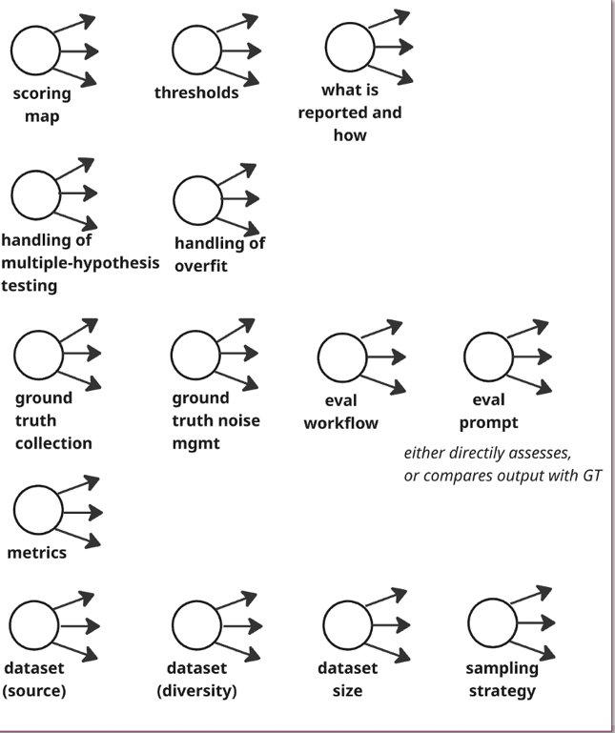
- LLM judge calibration: Does the judge's assessment correlate with what humans actually care about? A judge might love verbose summaries while your users want brevity.
Each of these adds variance. Each can introduce bias. And each is sufficient to flip your decisions—about what to ship, and about which direction to iterate.

If you are comparing two prompt variations. System A scores 79%, system B scores 85%. You pick B and move forward. But with ±8 points of variance on each measurement, system A might actually be better. With a 30-40 points interval, it’s a randomizer. You just iterated in the wrong direction—and you have no way of knowing, unless after 4 months into production.


Mandates, Practices, and Tools
Because eval is hard and we are doing AI at scale, across many teams, organizations try to assist their teams by provide mandates, tools, best practices documents and other guidelines, such as
- Mandates: "All teams should have at least 100 ground truth examples "
- Standard metrics: "Use technical accuracy, completeness, and safety"
- Recommended eval prompts: "Here is the prompt to assess technical accuracy"
- Maps – from eval prompt output to numeric score: added as default in the eval suite.
- Tools: eg for synthetic data generators, LLM-as-judge implementations
- Guidelines: Documentation on how to construct test cases, how to interpret scores

Challenges with mandates
This feels like progress. It's systematic. It's scalable. It brings some consistency across teams. Executives see the same metrics and the same reports structure. It brings order into chaos.
And, it comes from a genuine desire to help teams that don't have deep expertise in evaluation methodology. Indeed, all of the above is useful, if used right.
These mandates come from the right place: helping teams who don’t have the time or expertise to design evaluations from scratch. However, in my experience, mandates and tools solve part of the problem — but without clear ownership, teams can reasonably assume that “just” following the mandate means that they are doing “eval” right for their use cases.
Only teams that are
- competent in “eval”,
- confident enough to deviate from defaults
- accountable for evals being representative of customer outcome

can successfully benefit from mandates and tools – with one exception discussed in section 4.
To see this, consider three concrete examples.
Example 1: The standard eval prompt
A central team develops an eval prompt for "technical accuracy" and recommends it to all product teams. A team building a legal summarizer adopts it. They run their eval, get 84%, and ship. Six months later, customers complain about factual errors. Investigation reveals that the standard prompt emphasizes fluency and coherence but doesn't penalize subtle factual mistakes—which matter enormously for legal documents. The prompt was designed for a different use case.
The team followed the guidance. The guidance didn't fit. But because there was an "official" prompt, the team didn't think critically about whether it measured what mattered for their specific application.
Example 2: The 100 test case mandate
A mandate requires 100 test cases before shipping. A team curates 100 examples, runs their eval, and passes. They've met the requirement.
But nobody asked: Are these 100 examples representative of production? Do they cover the diversity of inputs the system will see? Were they generated synthetically or drawn from real data? Will we overfit? (yes) Will we test multiple hypotheses? (yes).
Teams who do not understand the nuances may optimize for the mandate—not for understanding their system.
Example 3: The synthetic data generation tool
A platform team builds a tool that generates synthetic test cases for any use case. Product teams adopt it enthusiastically—it's faster than collecting real data and avoids privacy concerns.
A team generates 500 synthetic test cases, runs a thorough evaluation, and reports strong results. In production, performance is much worse. The synthetic data was clean, well-formed, and unambiguous. Real data are messy, multilingual, full of typos, and often combine multiple requests in one message – and, most importantly, they carry nuanced connections.
The tool made it easy to generate data. It didn't make it easy to generate representative data, and it may not even provide tools to compare real vs generated data. The team assumed the tool – developed by competent scientists - solved the problem.

These examples illustrate several patterns:
False confidence. Ad-hoc evaluation is obviously shaky—But "I used the official tool and followed the guidelines" feels rigorous. It creates confidence that may not be warranted, and that confidence is harder to question. Who wants to challenge the official process?
Responsibility diffusion. When something goes wrong, everyone can point elsewhere. The product team says: "We used the recommended prompt." The platform team says: "We provided the tool; how teams use it is up to them." The central AI team says: "We set the standards; implementation is the product team's responsibility."
Mandates and tools, when not structured in a process and org culture, can create the appearance of process without clarifying who is actually accountable for the reliability of the evaluation.
Optimization to the mandate. Once a mandate exists, teams optimize for passing it. "We need 100 test cases" becomes the goal, rather than "we need to understand how this system behaves." The mandate becomes a ceiling, not a floor.
Suppressed critical thinking. When there's an "official" way to do things, questioning it can feel like unnecessary overhead—or worse, like not being a team player. Teams that might have thought carefully about what matters for their specific use case instead accept defaults. The defaults may not fit, but deviating requires justification that following the standard does not.
Harder diagnosis. When production problems emerge, tracing back to root cause becomes harder. "We followed the process" is a dead end. The process itself is rarely examined, because it was blessed by a central team. The search for causes focuses on implementation details rather than methodological choices.
What's missing is not more mandates or better tools. What's missing is accountability for the reliability of the evaluation itself—not just for following the process, not just for producing a number, but for understanding what the number means and how much confidence it warrants.
This requires:
- Someone who owns the full chain, from metric definition to data sampling to judge calibration to uncertainty quantification
- A culture where "I used the standard process" is the beginning of a conversation, and is always followed by “here is why the standard process applies to my case and here is the evidence I have” – or “here is why I deviated”
- Recognition that evaluation methodology requires judgment, and that judgment requires ownership
The next section explores what that accountability might look like in practice—and how to address the visibility, culture, and action problems that make rigorous evaluation so difficult.

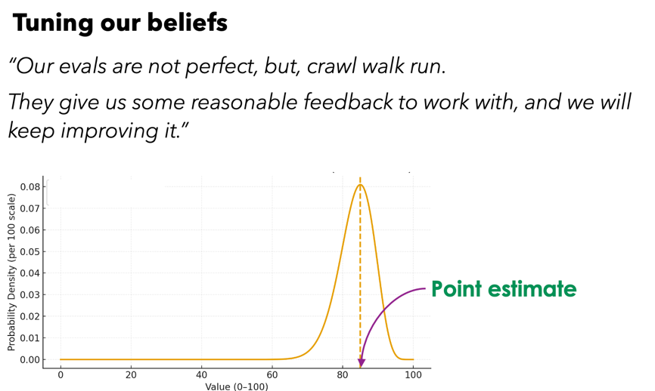Expectation

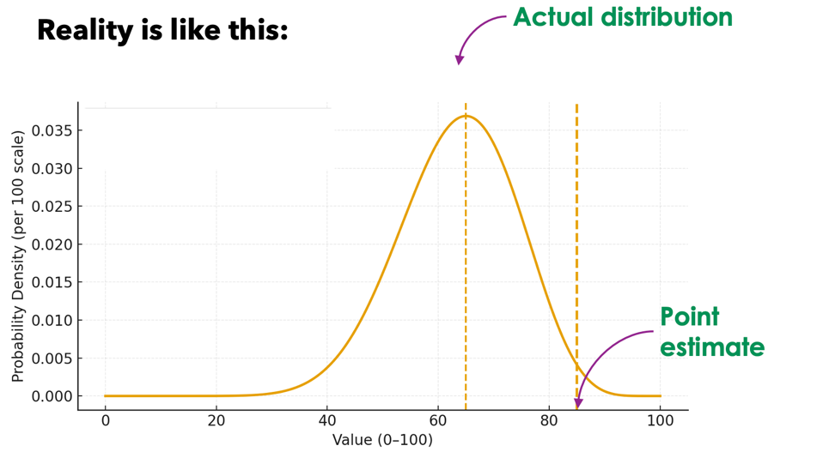

Engineering Processes and Practices
One of the problems this complexity creates is that it makes it unclear who is responsible if the application quality. This is new: it was not the case in SW 1.0, nor was it in 2.0.
In Software 1.0, we spent decades building mature engineering practices. Version control. Code review. CI/CD pipelines. Staging environments. Change management. Everything that could affect system behavior went through a visible, reviewable artifact—a pull request, a test plan, a deployment pipeline.
In Software 3.0, much of this discipline dissolves. Everyone is acting reasonably within their understood scope. The problem is that rigorous evaluation falls between these scopes. It requires someone to own the full chain—from metric definition to data sampling to judge calibration to uncertainty quantification. In most organizations today, this responsibility hasn't found its home.
Our engineering infrastructure was built for code. We have sophisticated systems for tracking code changes, reviewing code, testing code. We don't have equivalent systems for tracking prompt changes, reviewing evaluation methodology, or versioning the full stack of prompts + models + data + tools that together define system behavior. The result is that Software 3.0 development often operates with less visibility, less traceability, and less rigor than Software 1.0—even as the systems become more consequential.

What To Do About It
Recall the three facets of the problem we identified:
- The visibility problem (epistemic): People don't see the uncertainty. It's not reported, not computed, not surfaced.
- The culture problem (organizational): Even when people could see uncertainty, the organization doesn't ask. There's no upside to surfacing it.
- The action problem (methodological): Even when uncertainty is visible and the culture asks about it, people don't know what to do.
The solutions must address all three.

Addressing the Visibility Problem
The visibility problem has three parts: we are not aware of uncertainty, we don't estimate it, and we don't report it.

The visibility problem has three parts: we are not aware of uncertainty, we don't estimate it, and we don't report it. Each must be addressed in turn.

Awareness
Before we can estimate or report uncertainty, people must understand that it exists—and that it matters. This requires education on several fronts:
- The many sources of bias and variability
- The impact of each on the final uncertainty window
- The impact that this in turn has on our ability of developers and of AI code generation to iterate and take decisions
Several approaches can help:
The first is just asking the teams to quantify it, even as ballpark. This by itself will start creating awareness.
Next, show, don't tell. Let people see the variability in their own work. Make it a point for teams to report on the variability they experienced and begin to make this a routine aspect of their presentations. Take an existing eval. Run it with three reasonable variations of the eval prompt. Show the team the spread. If the scores are stable, that's reassuring. If they diverge by 15 points, that's a lesson no lecture can match. The same can be done with different samples from the same dataset, or with different judges. One demonstration on your own data is worth ten explanations of the theory.
Use thinking tools and Leverage AI assistants (detailed later)
- Worksheets can act as “thinking” tools that confront questions they might otherwise skip: "How do you know your data is representative?" "What's your confidence interval?" "How many variants did you test on this dataset?" The act of answering—or discovering you cannot answer—creates awareness.
- Leverage AI assistants. An AI "Center of Excellence" agent, grounded in evaluation best practices, can ask the probing questions that busy teams forget to ask themselves. "You're reporting 85% on 50 samples—are you comfortable that the true accuracy might be 75%?" This scales the function of a skeptical reviewer to every team.

Make uncertainty visible by default. When dashboards and reports show confidence intervals rather than point estimates, awareness becomes unavoidable. People cannot ignore what is in front of them. Changing the defaults changes the culture.
None of these require teams to become statisticians. They require only that teams see the variability that was always there but hidden—and that they see it often enough that it shapes how they think.
Awareness is a precondition for everything else. You cannot estimate what you don't know exists, and you will not report what you haven't estimated.

Estimation
Once aware, the next step is to quantify—or at least bound—the uncertainty. For some sources, standard methods exist (confidence and credibility intervals, impact of noisy judges, bias created by multiple hypotheses testing,. …).
For other sources, precise quantification is harder. For example, for Data representativeness: How different is your test set from production? Often we cannot know precisely, but we can ask: Is this synthetic or real data? Does it cover the diversity of inputs we expect? Are there known gaps? In these cases we often cannot produce a number. We can only probably go by experience and “ballpark it” – this is better than nothing and we will get better over time at estimating this.

Reporting Uncertainty
Once uncertainty has been estimated—even approximately—it must be communicated.
The only exception is when the magnitude of uncertainty is irrelevant to the decision at hand. This is rare. For most ship/no-ship decisions, for most comparisons between system variants, uncertainty matters.
A common objection here is that "executives would not understand it." This is not true. Executives routinely deal with uncertainty in financial forecasts, market projections, and risk assessments. They may ask hard questions—"Why is the range so wide?" or "What would it take to narrow it?"—but these are exactly the questions that should be asked. Discomfort with the questions is not a reason to hide the answers.
In fact, once one team begins reporting uncertainty, something important happens: decision-makers start asking why other teams aren't doing the same. This creates pressure toward transparency. Reporting uncertainty is contagious in a way that benefits everyone.
What should reporting look like?
Instead of this:
Metric | Score
Technical Accuracy | 89% ✓
Completeness | 84% ✓
Calling Correctness | 72% ⚠
Consider this:
Metric | Estimated Range | Confidence Notes
Technical Accuracy | 80–94% | Based on 100 samples; prompt sensitivity adds ~5 pts
Completeness | 75–90% | Synthetic data may not reflect production diversity
Calling Correctness | 62–82% | Small sample (n=50); wide interval expected
The second table says less with false precision and more with honest information. It invites the right conversations: "Can we get more data to narrow the Technical Accuracy range?" "What would it take to validate on real production samples?"
Exposing uncertainty to decision-makers is one of the two easiest and fastest ways to improve the situation. It requires no new tools, no new methods—only the willingness to show what we actually know.

Addressing the Action Problem

Reducing Uncertainty
Some uncertainty is actually avoidable. Before accepting bias and uncertainty, ask: can we reduce them? The answer is that in most cases – yes, we can.

Some examples:
Eval at scale on customer data: Uncertainty (and bias) in sample size and data representativeness can be reduced by running evaluations on customers data, and at scale. Sometimes this is not possible, but often this is not done as it may be time consuming, or due to the belief that we need human labelers to generate ground truth.
This is a false belief: I am yet to see a case where humans are consistently better than LLMs in assessing an <input, output> pair. When that happens, it is likely that eval guidelines are not well specified, or that the eval is subjective.
I am also yet to see a case where synthetic data is as nuanced as actual, production data. It may be – but that is a feat hard to achieve (not to mention that each use case, each domain, each customer is different).
Notice that if we eval at scale, we also greatly reduce the multiple hypotheses testing problem. If we have data at scale, we can have many holdout dataset, but in general a large and diverse test set by itself reduces the problem.

Doing this takes effort – and if the impact of uncertainty and bias is recognized, then leadership can ask to put more resources on this

As another example, we can spend more cycles on calibrating an LLM judge so that the noise due to errors in the eval judge is reduced. This, again implies effort and dedicated, qualified resources.
None of these eliminate uncertainty. But they can reduce it meaningfully—and just as importantly, they help you understand how much uncertainty remains. The really important shift is to begin asking the question: how can we reduce it? And – the awareness for how important it is to do so.

Develop Observability Concepts, Abstractions and Tools
We can borrow lessons from software engineering and apply them to AI systems to understand where low quality, unexpected behaviors occur.
This can be done by thinking from first principles and identifying concepts and abstractions that facilitate this. Here are some examples, based on needs emerged from actual production cases:
Agentic Assertions on inputs and outputs:
- Define expectations for what an agent or tool should receive and produce.
- These can be structural (format, schema) or semantic (intent, purpose).
- When assertions fail, you learn something—either about your system or about your expectations.
Introduce the concept of desirable (vs undesirable) agentic execution paths:
- For agent-based systems, some execution paths are expected, others are concerning.
- Define these explicitly. Monitor which paths are taken in production.
- Analyze at scale: in which cases do desirable paths get followed? What predicts failure?
Exception handling:
- What should happen when an agent encounters something unexpected?
- Define fallback behaviors. Make failures visible rather than silent.
This layer doesn't directly improve your eval scores. But it gives you ongoing visibility into whether your system is behaving as expected—and helps you catch problems that offline evaluation might miss. Based on this, we iterate and improve the system to reduce sources of undesired variability.
Defining assertions and expectations in natural language may not be trivial, especially for non-engineers. But this is an area where AI assistants might help—guiding users through the process of articulating what they expect from a system.
Logging with appropriate granularity:
Everything above depends on logging. For AI agents, capture inputs, decisions, tool interactions, outputs, and metadata. Consider log levels that reflect agent concerns:
- TRACE: Full chain-of-thought (debugging only)
- EXECUTION: Key decision points and tool calls (standard production)
- OUTCOME: Final result and assertion violations
- EXCEPTION: Errors, fallbacks, undesirable paths
- AUDIT: Security-relevant events
And respect access controls—AI agent logs are sensitive, containing user queries and business data.

Use Worksheets as Thinking Tools
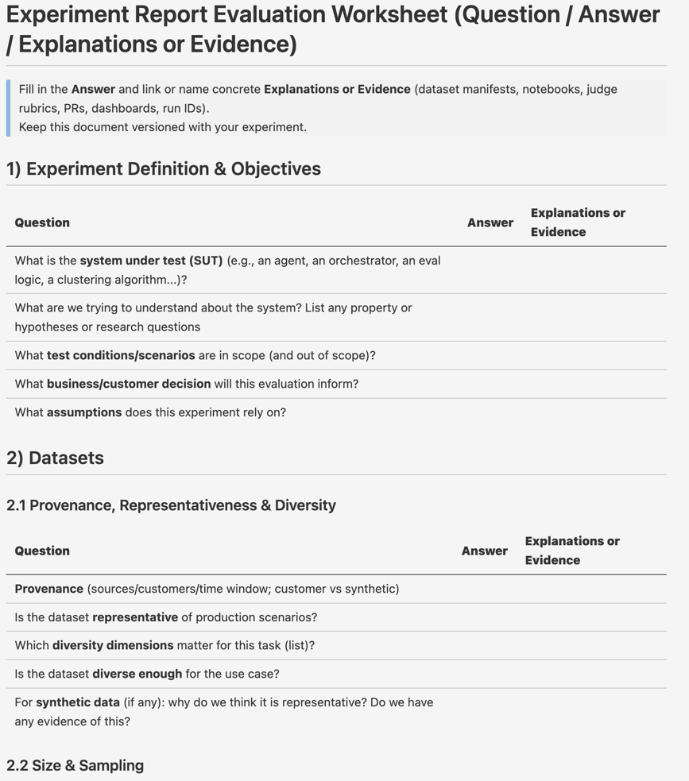
Worksheets are great tools to help thinking. They do not shift accountability or responsibility, but they help teams think about how the evaluation has been done. I believe a good worksheet has three “columns”: a question, an answer, and a request for evidence about the answer: how do we know?
The figure shows an example, taken from this worksheet.
It is ok to answer questions with an “I don’t know” or “it’s just my best guess” – but at least we know what we don’t know.

This isn't about catching people out. It's about making the gaps visible—to yourself and to others.
The worksheet can be easily filled automatically by an agent, given a report or a presentation. Then PMs can be aware of which parts are missing and complete them.

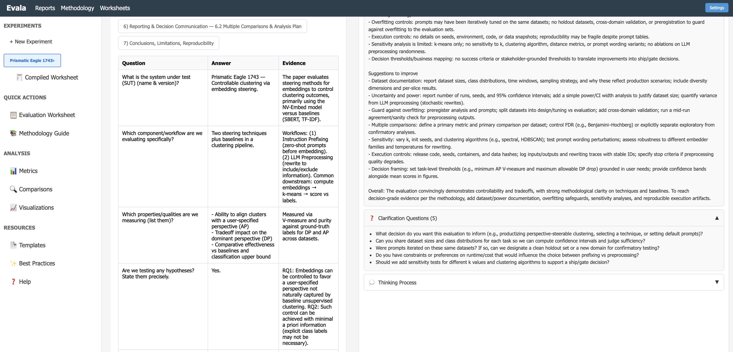

AI “Center of Excellence” agents
A Center of Excellence is valuable: experts who can review evaluation methodology, ask hard questions, and catch blind spots. But a small team of experts cannot review hundreds of evaluations across a large organization. The expertise becomes a bottleneck.
One approach: encode the function of the Center of Excellence into an AI assistant. An agent that:
- Knows the principles of rigorous evaluation
- Is aware of your organization's standards and practices
- Guides teams through the worksheet, asking probing questions
- Flags gaps and suggests improvements
- Helps fill in evidence or highlights where evidence is missing
This is not a replacement for human judgment. But it can scale the questioning—the part where someone asks "how do you know?" and "have you considered...?"
Think of it as a Center of Excellence at your fingertips. Not a rubber stamp, but a thinking partner that helps teams be more rigorous than they would be on their own.
The figure above shows a toy implementation – in progress.

Addressing the Culture Problem
Everything above—the techniques, the tools, the processes—requires a cultural foundation.
Teams need to feel safe saying "we don't know." Executives need to accept that "82% ± 8 points" is more valuable than "82%"—even though it feels less confident.
This is perhaps the hardest part. Organizations prefer harmony. Point estimates feel decisive. Uncertainty feels like weakness.
But uncertainty isn't weakness. Pretending certainty where none exists—that's weakness. It leads to false belief, bad decisions, and eroded trust when reality catches up.
The goal isn't to eliminate uncertainty. It's to see it clearly, communicate it honestly, and make good decisions despite it.

Three things can shift culture quickly:
- Naming things right: This is an *instant* way to address the issue. Naming always gets you a third of the way there. If we stop calling this “eval” and start calling it “estimation of random variables”, by itself this will create teams and execs to put the attention in the right place.
- Asking the questions: having executives asking the questions gets us another third of the way there. It instantly creates the right culture. Instantly.
- Make accountability explicit. Every evaluation should have clear ownership—not for producing a good-looking number, but for the reliability of the number. Someone should be accountable for:
- Why these metrics matter
- Whether the methodology is sound
- What the uncertainty range is and why
- Whether the result is ready to inform decisions

The next time you see a scorecard with a green 89%, ask:
What range would you sign your name to?
What would you tell a customer if they asked—and you had to stand behind the answer?
What range would you be comfortable owning when this goes to production?
If the team can't answer, the number isn't ready. And neither is the decision.

